CHAPTER 14 BITMAPS AND BITBLTS

Unveiling the World of Bitmaps and Bitblts in Windows

This chapter dives into the fascinating realm of bitmaps and bitblts, essential tools for manipulating and displaying images in Windows applications. Let's embark on a journey through their intricate workings:

What are Bitmaps?

Imagine a rectangular grid overlaid on an image. Each tiny square within this grid represents a pixel, the basic unit of visual information.

A bitmap, in its simplest form, is a two-dimensional array of bits corresponding to these pixels. Each bit value determines the pixel's color or intensity, with 1 representing "on" and 0 representing "off."

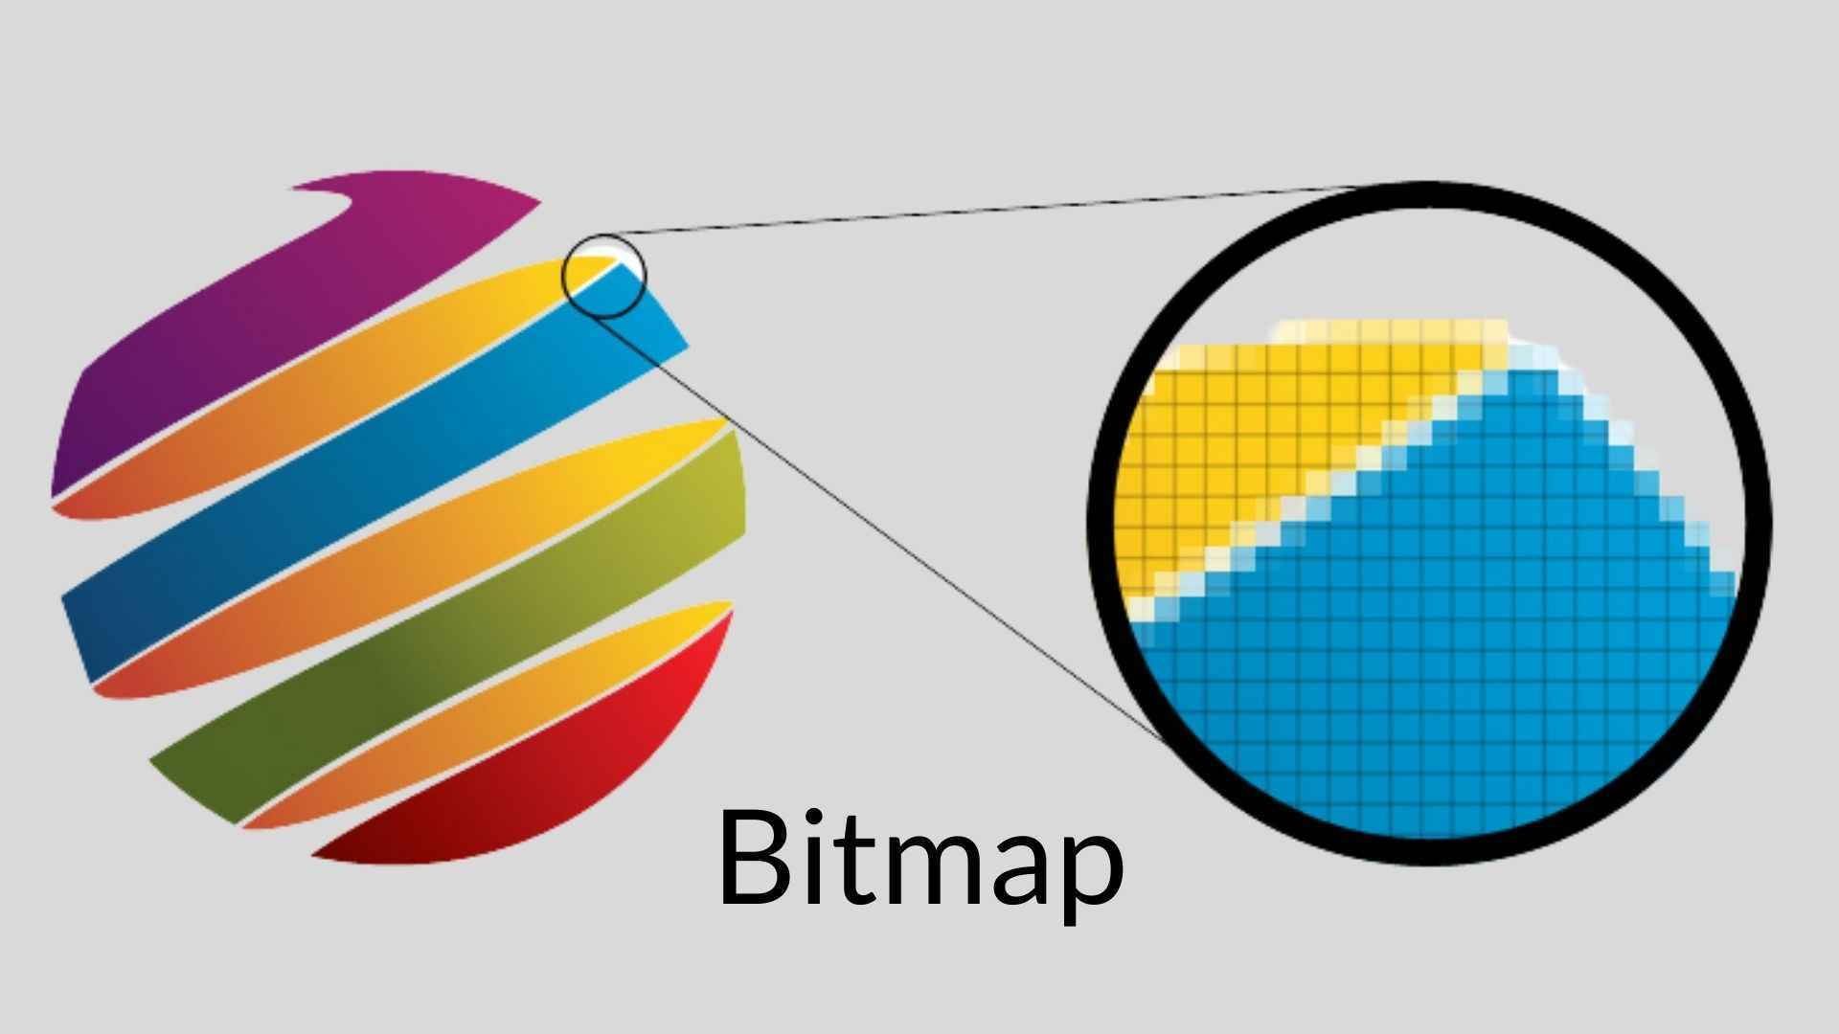

Shades and Colors: Beyond Binary

While monochrome bitmaps require just one bit per pixel, the world of images is often richer than black and white.

For shades of gray or vibrant colors, multiple bits per pixel come into play. Each bit acts as a tiny brushstroke, contributing to the overall color palette.

Think of it as a mosaic, where combinations of these individual bits build the intricate tapestry of the image.

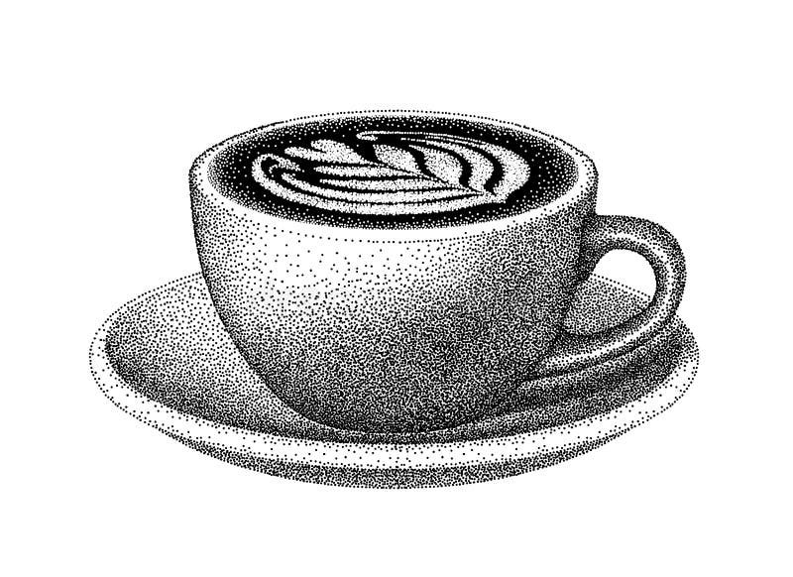

Bitmaps vs. Metafiles: Two Approaches to Pictorial Data

Windows offers two main approaches to storing pictorial information:

Bitmaps: As described above, bitmaps directly represent the digital image data, essentially a snapshot of the pixels and their colors. They are efficient for simple images but can become bulky for complex ones.

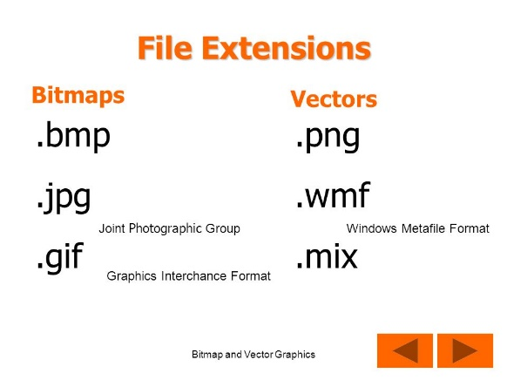 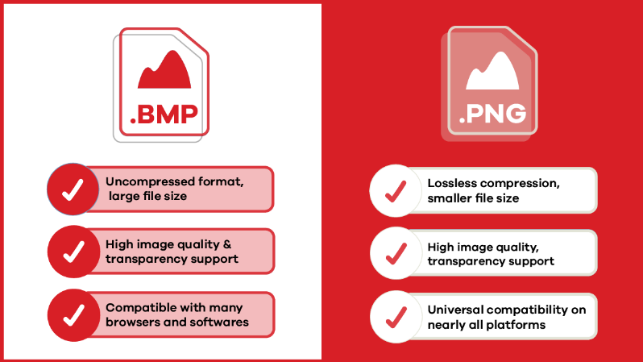

Metafiles: These store a set of instructions for drawing the image, similar to a recipe for creating the visual output. They are compact but require processing power to render the image on-screen.

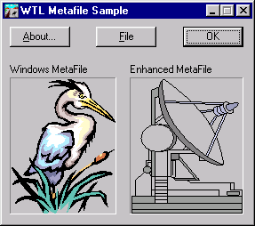

GDI Bitmaps: The Predecessors to DIBs

Before the introduction of device-independent bitmaps (DIBs) in Windows 3.0, GDI bitmaps reigned supreme. This chapter focuses on these pre-DIB bitmaps, showcasing their power and versatility even in the face of their later counterparts. Don't underestimate their value!

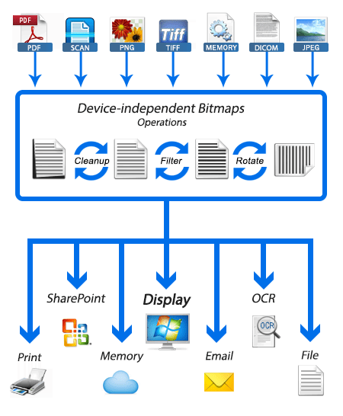

Bitblts: The Magic of Copying and Combining Images

Bitblts, short for bit block transfers, are the workhorses of image manipulation in Windows. They allow you to copy or combine rectangular regions of bitmaps, essentially transferring blocks of pixels from one location to another. Think of them as the paintbrushes and palettes of the digital world, enabling you to blend, move, and manipulate images with precision.

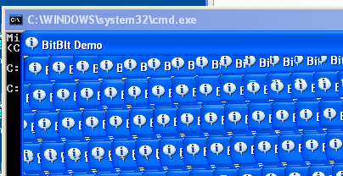

Exploring the Chapter's Depths:

Through a series of sample programs, this chapter delves deeper into the practical applications of GDI bitmaps and bitblts. You'll learn how to:

* Create and manipulate bitmaps using GDI functions.
* Load and display images from various formats like BMP and ICO.
* Copy and move portions of images using bitblts.
* Combine multiple images into a single composition.
* Apply transparency effects to create layered visuals.

Beyond the Basics:

This chapter lays the foundation for further exploration. You can dive deeper into topics like:

* Advanced bitblt operations for sophisticated image manipulation.
* Optimizing bitmap performance for efficient memory usage.
* Leveraging DIBs for device-independent image handling.

Embrace the Power of Bitmaps and Bitblts:

By understanding the concepts presented in this chapter, you unlock a powerful toolset for creating visually compelling applications in Windows. Remember, bitmaps and bitblts are not relics of the past; they remain valuable building blocks for modern image-centric applications. So, grab your digital paintbrush and start exploring the boundless possibilities of these fascinating tools!

DELVING DEEP INTO BITMAPS AND METAFILES: UNVEILING THEIR STRENGTHS AND WEAKNESSES

The digital world of images thrives on two distinct approaches: bitmaps and metafiles. Each holds its own advantages and drawbacks, shaping the way we create, manipulate, and share visual information. Let's dive deeper into their characteristics to understand their unique strengths and weaknesses:

Bitmaps: Capturing the Nuances of the Real World

Direct Representation: Imagine a detailed photograph. A bitmap captures it by meticulously recording the color or intensity of each tiny pixel, creating a digital replica of the real world with remarkable accuracy. This makes them ideal for complex images like scanned documents, photographs, and video captures.



Device Dependence: However, bitmaps come with a caveat – their close ties to specific devices. Colors might appear washed out on a monochrome display, and scaling often leads to distortion due to pixel manipulation.

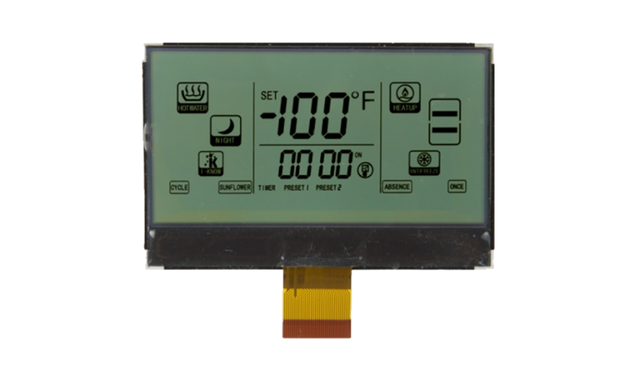

Storage Demands: The sheer amount of data required to represent every pixel can be substantial. A high-resolution image can easily consume megabytes of storage, posing challenges for transmission and archiving.



Metafiles: A Recipe for Scalability and Flexibility

Instructions, not Pixels: Unlike bitmaps, metafiles don't store the actual image data. Instead, they act like recipes, containing a series of instructions for drawing lines, shapes, and fills. This offers several advantages:

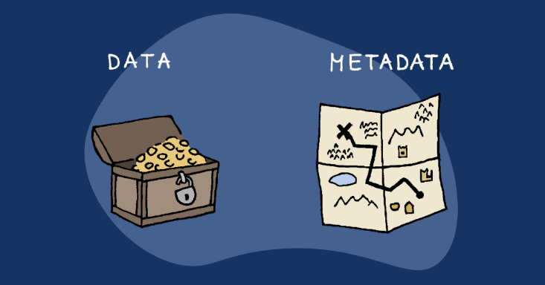

Device Independence: Metafiles can adapt to different devices and resolutions without distortion. The "recipe" adjusts automatically, ensuring consistent appearance across various displays and printers.

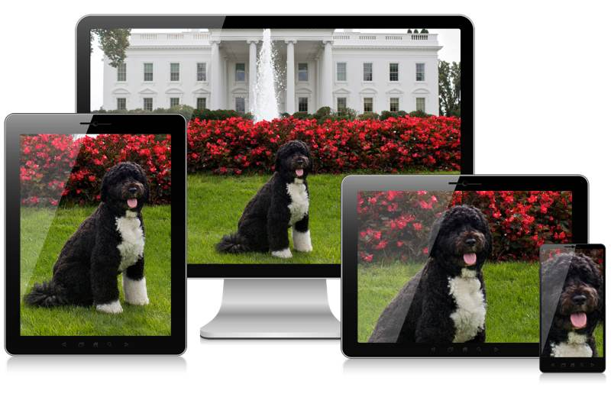

Scalability: Need a bigger image? Metafiles can be scaled up or down seamlessly without compromising quality, making them perfect for architectural drawings and diagrams.

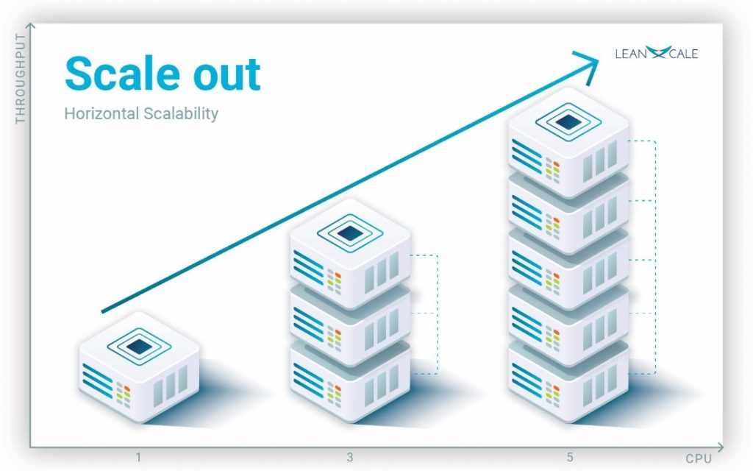

Compact Size: Compared to bitmaps, metafiles often require significantly less storage space. The instructions themselves are relatively small, making them ideal for sharing and transmission.

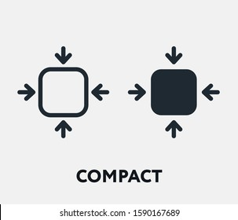

The Trade-off: Speed vs. Complexity

Speed Demon: When it comes to displaying simple images, bitmaps reign supreme. Copying a bitmap to the screen is a quick and efficient process, making them ideal for fast-paced applications like games and animations.

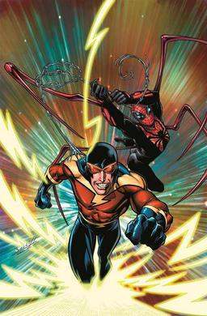

Processing Power: Metafiles, on the other hand, require more processing power to interpret their instructions and translate them into actual pixels. This can lead to slower rendering, especially for complex images.

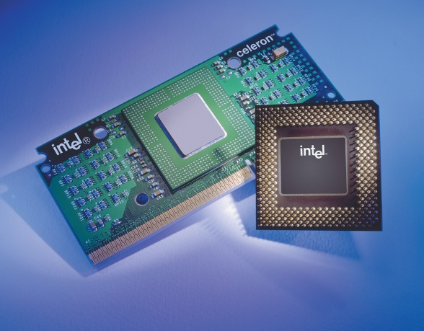

Beyond the Basics: Compression and Evolution

Compression Techniques: The storage demands of bitmaps have been addressed by compression algorithms. These algorithms can significantly reduce file size without sacrificing image quality, making bitmaps more manageable for transmission and storage.

DIBs and Beyond: The world of bitmaps continues to evolve. Device-independent bitmaps (DIBs) offer enhanced flexibility and device independence, while more advanced formats like JPEG and PNG provide efficient compression for various image types.

Choosing the Right Tool for the Job:

Understanding the strengths and weaknesses of both bitmaps and metafiles empowers you to make informed decisions about which approach to use. Consider factors like:

* Image Complexity: For intricate real-world images, bitmaps offer unmatched detail.
* Scalability and Flexibility: Metafiles shine when consistent appearance and adaptability are key.
* Storage and Transmission: If file size is a concern, metafiles generally take up less space.
* Performance: For fast-paced applications, the speed of bitmaps might be crucial.

Conclusion:

Bitmaps and metafiles are not rivals, but complementary tools in the digital artist's toolbox. Understanding their unique strengths and limitations allows you to leverage their power to create visually stunning and effective applications. So, choose wisely, experiment creatively, and let your imagination take flight in the world of digital images!



I hope this more in-depth explanation clarifies the differences and nuances between bitmaps and metafiles. Feel free to ask further questions or request specific aspects for deeper exploration! Remember, there's always more to discover in the fascinating world of computer graphics.

THE DIVERSE ORIGINS OF BITMAPS: A JOURNEY FROM MANUAL CREATION TO CAPTURED REALITY

Bitmaps, those ubiquitous building blocks of digital images, have a fascinating journey before they grace our screens. Their origins lie not only in the creative minds of artists but also in the intricate workings of hardware and the wonders of the real world. Let's delve into the diverse ways bitmaps come to life:

1. From the Artist's Brush to the Digital Canvas:

Manual Creation: Programs like Paint allow artists to directly create bitmaps. Each brushstroke, each pixel placed, becomes part of the final image. This approach is ideal for intricate details and artistic expression, where precise control over individual pixels is paramount.



2. Algorithmic Magic:

Code-Crafted Images: Not all bitmaps need a human touch. Computer code can generate intricate patterns, textures, and even fractals, often too complex to be rendered as vectors. These algorithmically generated landscapes and abstract creations push the boundaries of digital art.

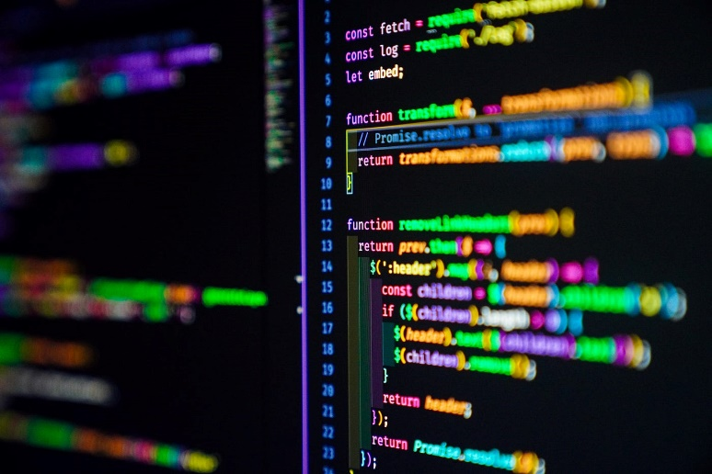

3. Capturing the Real World:

Hardware Heroes: This is where bitmaps truly shine, capturing the essence of the physical world. Hardware devices like scanners, camcorders, and digital cameras bridge the gap between reality and the digital realm.

Scanners: The veterans of the field, scanners use rows of CCD (charge-coupled device) cells to scan images, translating light intensity into electrical charges, then into digital values. With each scan, a line of pixels is captured, building the final bitmap representation of the scanned image.

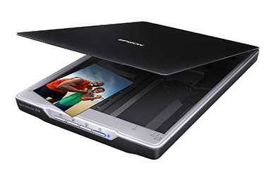

Camcorders: These video capture devices employ CCD arrays to capture video frames, which can be stored on tape or, more recently, converted directly into bitmaps using video frame grabbers. This allows you to grab individual frames from videos, creating still images from your favorite movies or TV shows.

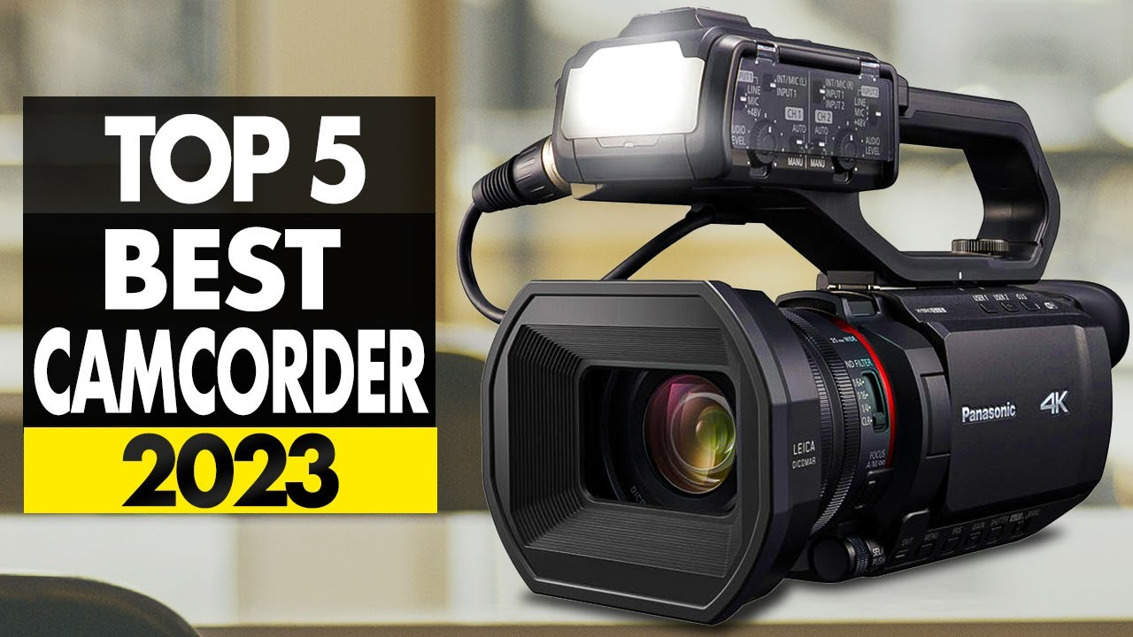

Digital Cameras: The latest stars of the show, digital cameras have made capturing bitmaps accessible and affordable. Their internal CCD arrays and ADCs convert light directly into digital images, stored within the camera itself. These images can then be transferred to computers for editing, sharing, and creative exploration.

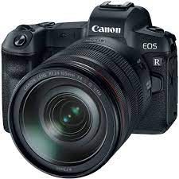

Beyond the Basics:

Beyond CCDs: While CCDs are the dominant technology, other sensors like CMOS (complementary metal-oxide-semiconductor) are also used in image capture devices.

Image Compression: The quest for efficient storage has led to various compression algorithms that reduce bitmap file size without sacrificing significant image quality.

The Future of Bitmaps: As technology advances, expect even higher resolutions, faster capture speeds, and even more sophisticated algorithms for generating and manipulating bitmaps.

Conclusion:

* Bitmaps are not just pixels on a screen; they represent diverse creative expressions, captured moments from the real world, and the ever-evolving landscape of digital imaging technology.
* So, the next time you encounter a bitmap, take a moment to ponder its journey – from the artist's canvas, the intricate workings of a scanner, or the fleeting moment captured by a camera lens.
* Each bitmap tells a story, a testament to the creative power of humans and the ever-evolving world of digital imagery.

DEMYSTIFYING BITMAP DIMENSIONS: A DEEP DIVE INTO WIDTH, HEIGHT, AND COORDINATES

When it comes to bitmaps, understanding their dimensions is crucial. It's the foundation upon which their visual information rests, dictating their size, resolution, and even interaction with other elements. Let's delve deeper into the fascinating world of bitmap dimensions:

Rectangular Wonders:

At their core, bitmaps are rectangular grids of pixels, each representing a tiny dot of color or intensity. This grid defines the image's spatial dimension, measured in pixels: width and height.

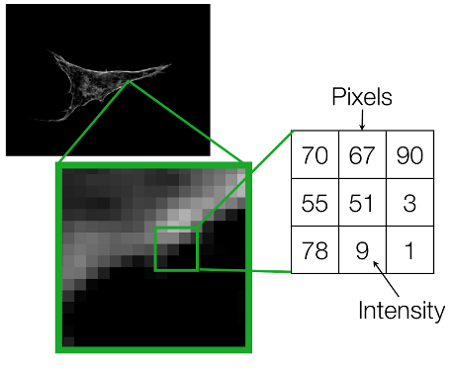

Shorthand Notation:

To avoid cumbersome phrases, we often use a concise notation for a bitmap's dimensions. For instance, "9 by 6" describes a bitmap 9 pixels wide and 6 pixels high. Remember, the width comes first by convention.

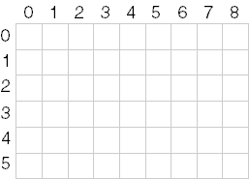

Pixel Power:

The total number of pixels in a bitmap is calculated by multiplying its width and height. In our example, 9 pixels x 6 pixels = 54 pixels. We often use cx and cy (count x and count y) to represent width and height, respectively.

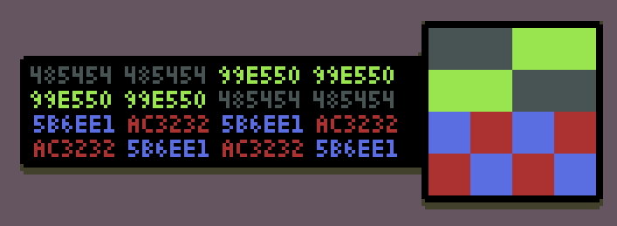

Coordinates: Pinpointing Pixels:

Each pixel within a bitmap holds its own unique location, identified by its x and y coordinates. By convention, the upper left corner is considered the origin (0, 0). Following this system, the bottom right pixel in our 9x6 example would be located at (8, 5) – one less than the width and height because numbering starts at zero.

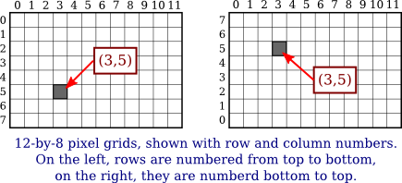

Resolution: A Confusing Term:

The term "resolution" can be tricky when discussing bitmaps. It can refer to both:

* Display Resolution: This refers to the number of pixels a display device like a monitor can show, often expressed as "640x480".
* Pixel Density: This refers to the number of pixels per unit of measurement, like "300 dots per inch" for a printer.

For bitmaps, focusing on pixel density as "resolution" provides a clearer understanding of their detail level.

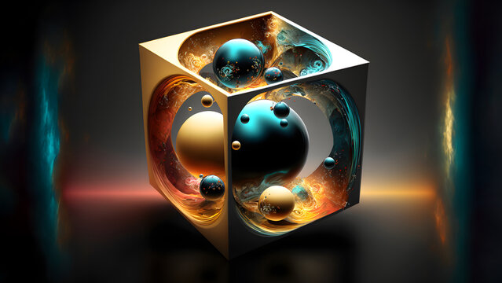

Memory Maze: Storing Bitmaps Linearly:

While bitmaps are rectangular, our computers store information linearly. Therefore, bitmaps are typically stored in memory row by row, starting with the top row and ending with the bottom. Each row, in turn, stores pixels from left to right, mimicking how we write lines of text.

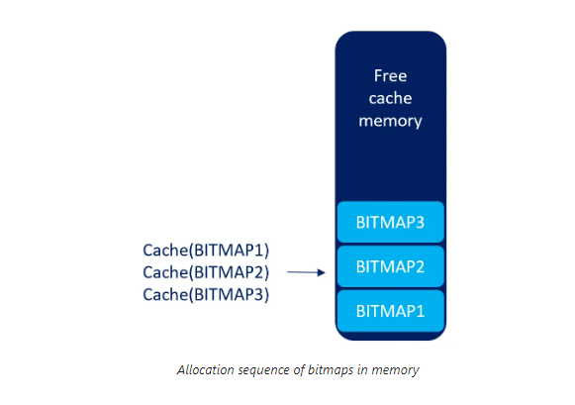

The Exception: DIBs and Beyond:

It's important to note that not all bitmaps conform to this linear storage model. Device-independent bitmaps (DIBs), for instance, store information differently, offering greater flexibility and device independence.

Understanding Dimensions: A Key to Success:

Grasping a bitmap's dimensions is essential for various tasks:

Scaling and manipulating images: Knowing the width and height allows for proper resizing and adjustments without distortion.

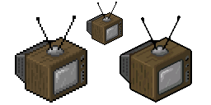

Extracting specific pixels: Coordinates enable access and manipulation of individual pixels within the bitmap.

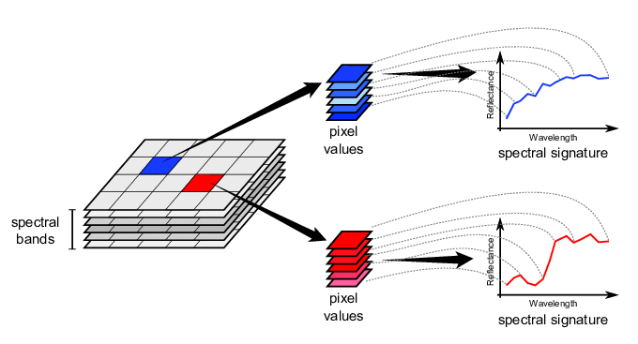

Aligning with other elements: Understanding dimensions becomes crucial when placing bitmaps alongside other visual elements within an application or user interface.

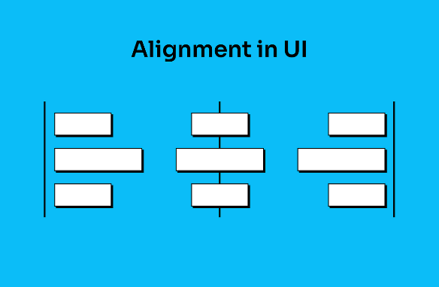

UNVEILING THE MYSTERY OF COLOR IN BITMAPS: A DEEP DIVE INTO BIT DEPTHS AND PALETTE MAGIC

Beyond their width and height, bitmaps possess another crucial dimension – color. This dimension, defined by the number of bits allocated to each pixel, determines the richness and complexity of the visual information they can display. Let's explore the fascinating world of color within bitmaps:

Bit Depth: The Language of Color:

Each pixel in a bitmap speaks the language of bits. The number of bits assigned to it, known as the bit depth or color depth, determines how much color information it can carry. This depth acts like a vocabulary, defining the range of colors a pixel can express.

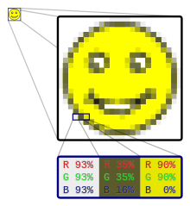

Monochrome Masters: Bilevel and Beyond:

At the simplest level, a bitmap can have just one bit per pixel, making it a "bilevel" or "monochrome" image.

This binary world allows only two states: on (typically white) or off (typically black). While seemingly limited, these monochrome masters excel in sharp lines, intricate patterns, and classic artistic expressions.

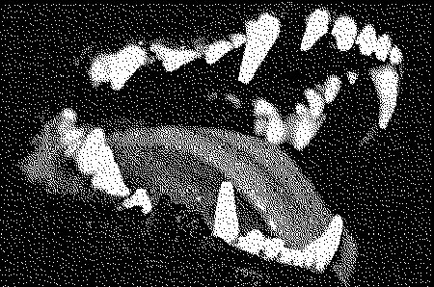

Beyond Black and White: Expanding the Palette:

With more bits come more colors. Each additional bit doubles the potential color combinations, opening doors to a richer palette. Two bits offer four colors, four bits offer sixteen, and so on. This exponential growth allows bitmaps to paint a broader spectrum of the world around us.

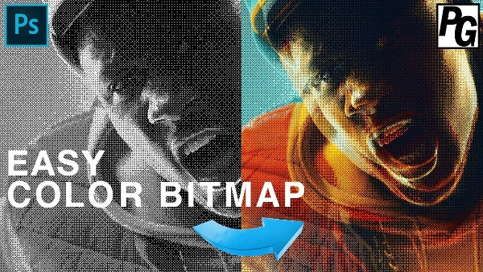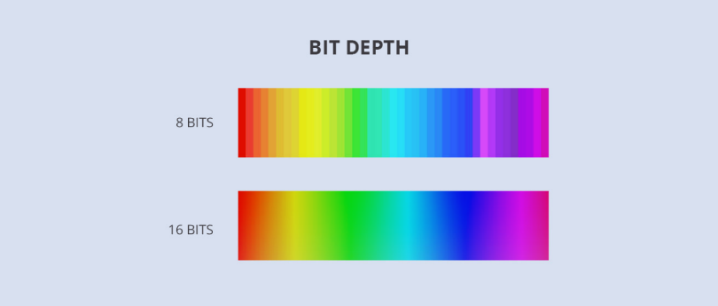

The Magic of 8-bit Palettes: A Familiar Canvas:

For decades, the 8-bit world reigned supreme in digital art and early computing. With 256 possible colors, it struck a balance between complexity and practicality. Artists crafted vibrant palettes, each pixel carefully chosen to depict landscapes, characters, and objects in a captivatingly pixelated style.

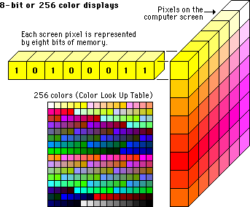

Pushing the Boundaries: 16-bit, 24-bit, and Beyond:

The quest for photographic realism led to higher bit depths. 16-bit bitmaps offered a staggering 65,536 colors, while 24-bit bitmaps, the standard for modern displays, boast a mind-boggling 16.7 million colors! This vast palette allows for near-photorealistic images, blurring the line between the digital and the real.

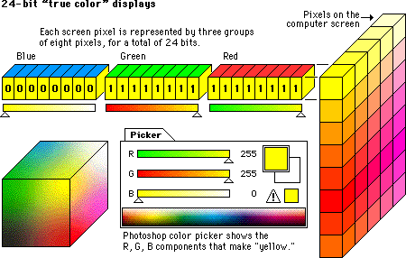

Decoding the Color Code: From Bits to Familiar Hues:

But how do these bits translate into actual colors? This is where the magic of color mapping comes into play. Each combination of bits corresponds to a specific index in a palette, a collection of pre-defined colors.

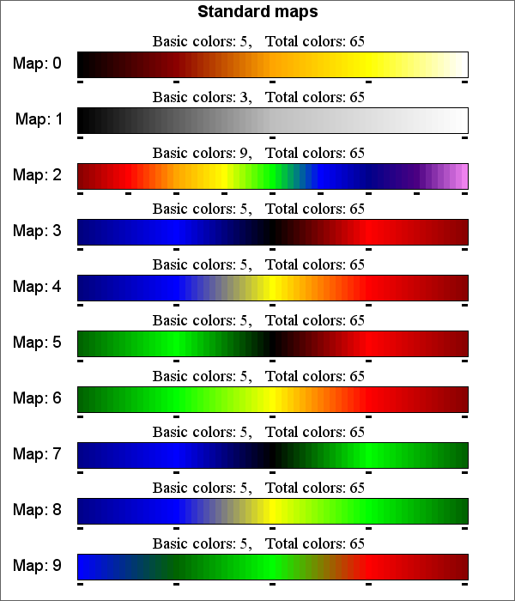

The operating system or application maintains this palette, and the bitmap simply references the indexes to paint its pixels. Understanding this mapping system empowers you to manipulate palettes, create custom color worlds, and inject your own artistic vision into your bitmaps.

Beyond the Basics: Dithering, Transparency, and More:

The world of color in bitmaps is vast and ever-evolving. Techniques like dithering simulate additional colors with limited bit depths, while transparency allows bitmaps to blend seamlessly with other visual elements. The possibilities are as limitless as your imagination.

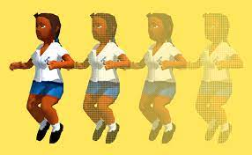

Color in bitmaps is more than just a technical specification; it's a language, a tool, and a canvas for artistic expression.

By understanding the intricacies of bit depths, palettes, and mapping techniques, you unlock the potential to create stunning visuals, tell stories with pixels, and push the boundaries of digital art. So, grab your digital brush, delve deeper into the world of color, and let your creativity flow!

Let’s goo….!!

DEMYSTIFYING BITMAPS AND REAL-WORLD DEVICES: A DIVE INTO COLOR DEPTHS AND HISTORICAL CONTEXT

The world of bitmaps is not just a realm of pixels and numbers; it's also deeply intertwined with the evolution of computer hardware and visual display technology. Let's take a deep dive into how real-world devices influenced bitmap formats and color capabilities throughout Windows history.

From Monochrome to Multicolor: A Journey through Video Display Adapters:

Monochrome Masters: In the early days of Windows, the Hercules Graphics Card (HGC) reigned supreme as the monochrome champion.

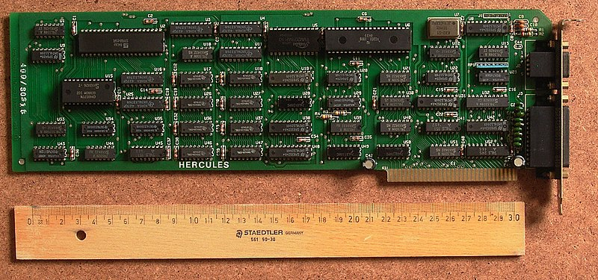

Its bitmaps, with only one bit per pixel, displayed stark black and white images, but they were perfect for text-based applications and laid the foundation for future advancements.

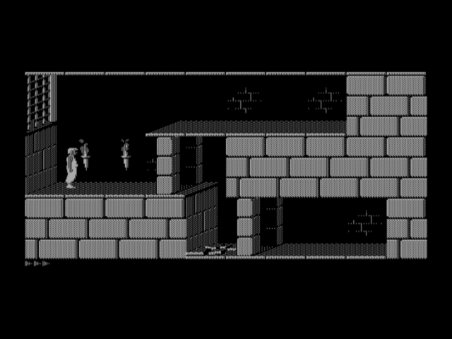

EGA, Embracing 16 Colors: The Enhanced Graphics Adapter (EGA) marked a pivotal moment, introducing 16 color capabilities to Windows users. Each pixel now held 4 bits of color information, allowing for basic representations of red, green, and blue alongside their darker and lighter shades. This palette, now considered the minimum standard for Windows, became the foundation for iconic Windows elements like mouse cursors and simple cartoon-like images.

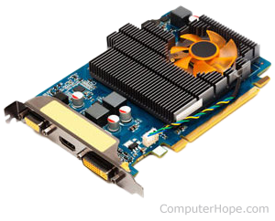

IRGB Encoding: A Legacy from Character Modes: The color encoding used in 16-bit bitmaps, known as IRGB (Intensity-Red-Green-Blue), actually originated from the IBM CGA's character mode colors. This system assigned 4 bits to each pixel, mapped in a specific way to the familiar hexadecimal RGB values used by Windows.

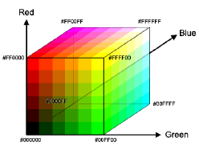

Beyond 16 Colors, A Spectrum of Possibilities:

While 16-color bitmaps hold historical significance and remain relevant for specific applications, the quest for richer visuals led to advancements in video display adapters:

VGA and Beyond: The Video Graphics Array (VGA) introduced an 8-bit color depth, offering a palette of 256 colors and enabling more complex images and vibrant artwork.

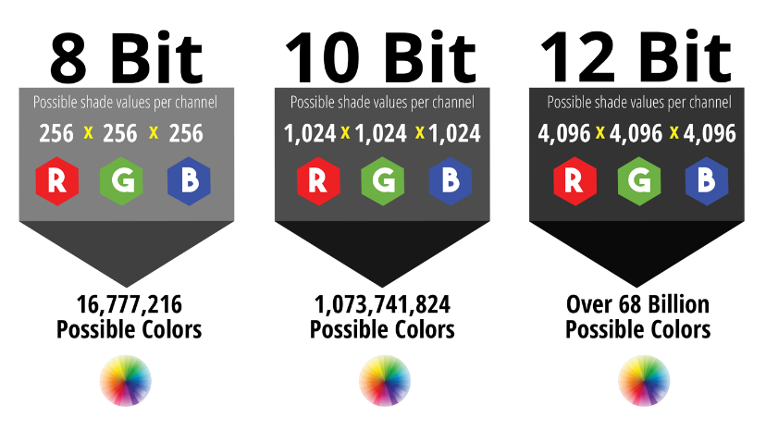

This further expanded the capabilities of Windows, opening doors to photorealistic graphics and detailed visual experiences.

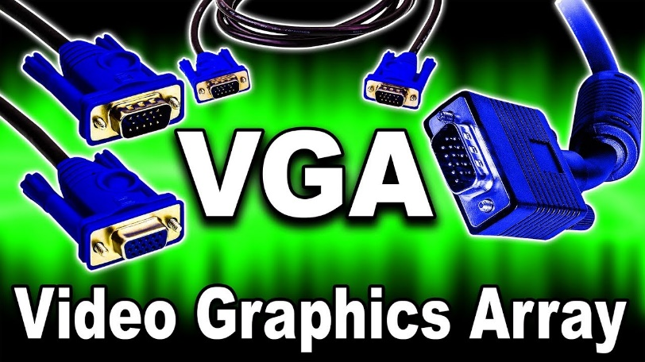

24-bit True Color: Embracing Millions of Hues: Today, with modern display adapters, we have 24-bit bitmaps, also known as True Color.

This format allocates 8 bits each for red, green, and blue, resulting in a staggering 16.7 million color combinations!

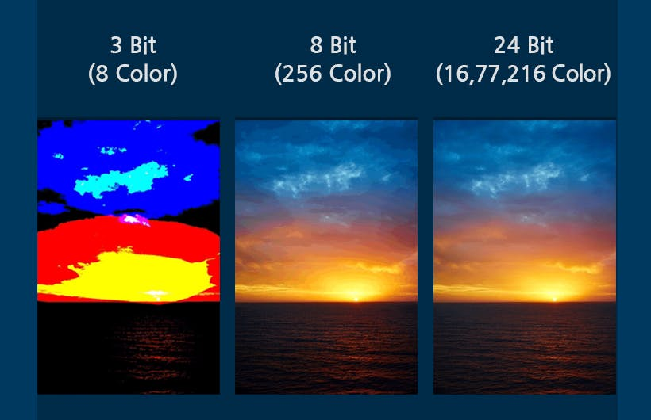

This allows for near-photorealistic visuals and unparalleled detail, blurring the line between the digital and the real.

Understanding the Connection:

By understanding how real-world devices like video display adapters influenced bitmap formats and color capabilities, we gain a deeper appreciation for the evolution of visual computing. This knowledge empowers us to:

Interpret historical visuals: Recognize the limitations and possibilities of older bitmap formats like 16-color IRGB encoding.

Choose the right format: Select the appropriate bitmap format based on the intended application, color requirements, and hardware compatibility.

Appreciate advancements: See the significant leaps in visual fidelity that have occurred with the development of new display technologies.

A Visual Guide:

To further solidify this understanding, consider this table summarizing the color depths discussed:

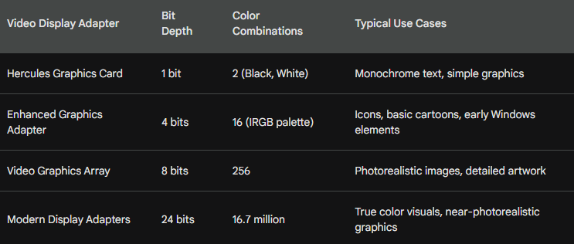

DELVING INTO THE COLORFUL WORLD OF VIDEO ADAPTERS AND BITMAPS: A DEEP DIVE

The world of bitmaps and their colors is more than just pixels and numbers; it's intimately intertwined with the evolution of video display adapters and the capabilities of different hardware configurations.

Let's embark on a deep dive into this fascinating realm, exploring the intricacies of color depths, memory organization, and the impact of historical hardware limitations.

16-Color IRGB: A Legacy from Character Modes:

While modern displays boast millions of colors, the early days of Windows relied on the humble 16-color palette.

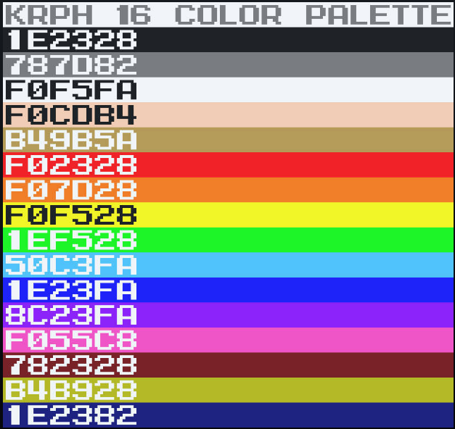 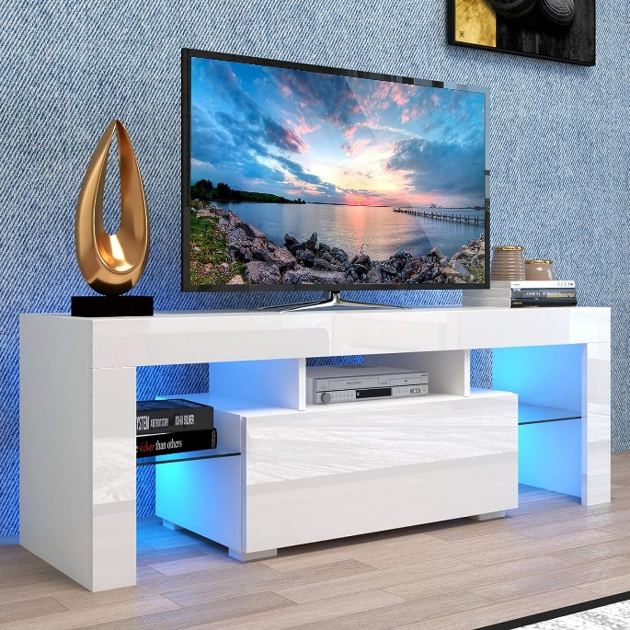

This limited spectrum, known as IRGB (Intensity-Red-Green-Blue), stemmed from the color limitations of the IBM CGA character mode.

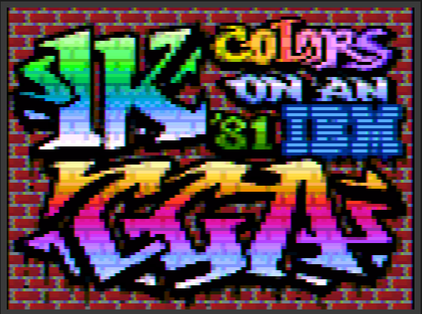

Each pixel was assigned 4 bits, mapped to specific hexadecimal RGB values as shown in the table below:

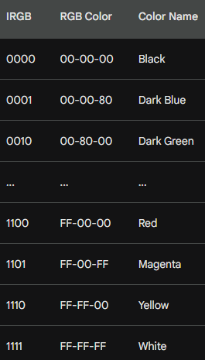

Memory Planes and Hardware Quirks:

The memory organization of the Enhanced Graphics Adapter (EGA) threw a curveball at programmers.

Instead of storing the four color bits consecutively for each pixel, the video memory was divided into separate "planes" for intensity, red, green, and blue.

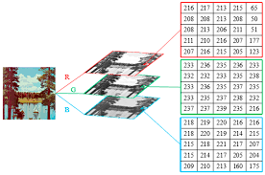

This device-specific quirk, thankfully, remained mostly hidden from Windows applications thanks to clever software handling.

From VGA to True Color, A Spectrum of Possibilities:

The limitations of 16 colors were soon overcome by the Video Graphics Array (VGA) in 1987.

This adapter offered a leap to 8 bits per pixel, allowing for a palette of 256 colors and unlocking the potential for more realistic visuals.

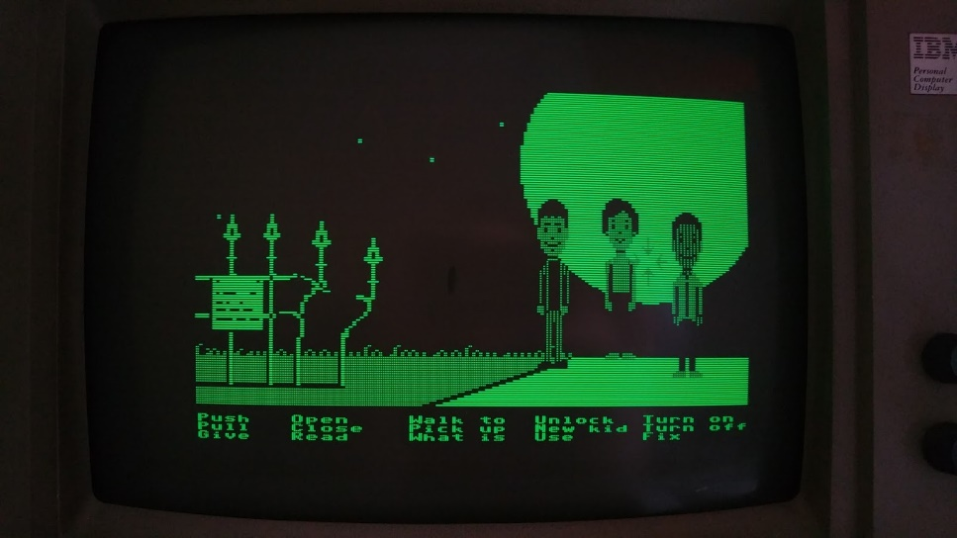

However, the original VGA required switching to a lower resolution mode for 256 colors, which wasn't ideal for Windows.

The arrival of Super-VGA (SVGA) adapters, with their standard 256-color support at 640x480 resolution, finally made this the norm.

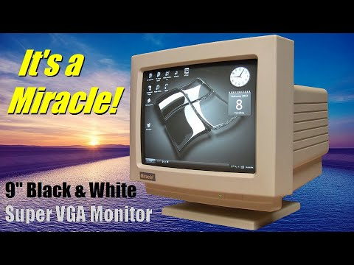

Palette Magic: Windows Takes Control:

While VGA offered 256 colors, Windows itself reserved 20 of them for system use. Applications accessed the remaining colors through the Windows Palette Manager, allowing them to customize and display real-world images effectively.

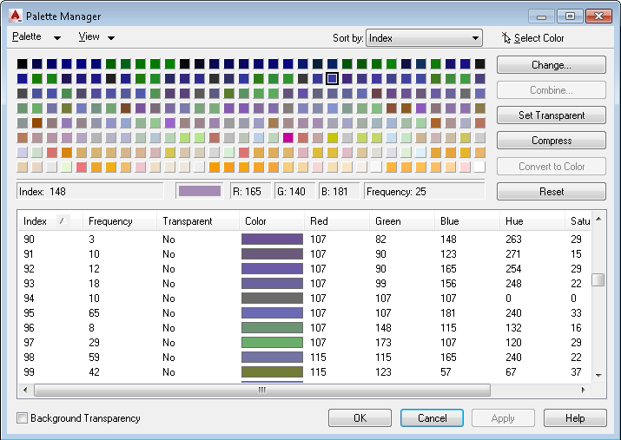

This table summarizes the reserved colors:

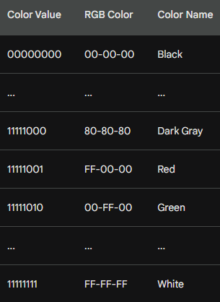

Moving Beyond the Limits: The Rise of High Color and True Color:

The quest for even greater visual fidelity led to the development of video adapters with 16 and 24 bits per pixel. These "high color" and "true color" adapters offered thousands and millions of colors, respectively, revolutionizing the way we experience visuals.

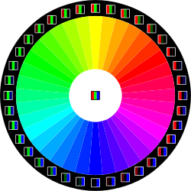

The 24-bit format, with its 3 bytes per pixel and ability to represent nearly the full spectrum of human perception, became the standard for years to come.

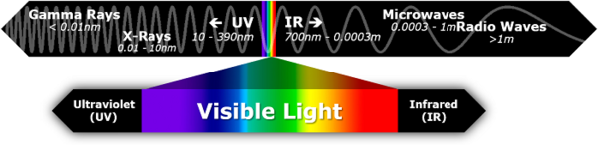

Understanding the Numbers, A Guide to Color Depths:

To navigate this colorful landscape, here's a quick reference table summarizing the discussed color depths and their characteristics:

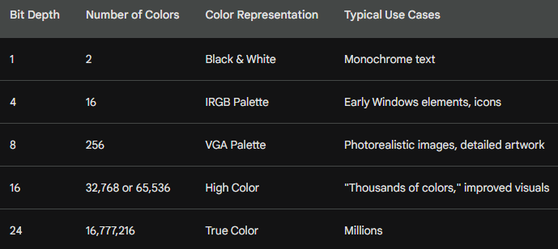

A DIVE INTO BITMAP SUPPORT IN GDI: FROM LEGACY TO MODERN MAGIC

The Windows Graphics Device Interface (GDI) has a long and fascinating history with bitmaps, spanning from its early days of monochrome displays to the vibrant world of millions of colors. Let's take a deep dive into this evolution, exploring the challenges and innovations that shaped bitmap support in GDI:

Early Days: GDI Bitmaps and Color Constraints:

In the pre-Windows 3.0 era, GDI bitmaps were purely tied to specific hardware limitations. These "GDI bitmap objects" existed as references tied to a display adapter's color capabilities.

Monochrome displays meant black and white bitmaps, and a 16-color VGA adapter restricted bitmaps to the IRGB palette. This limited flexibility, as bitmaps could not be readily moved between devices with differing color capabilities.

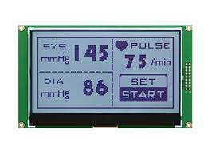

DIBs: Enter the Device-Independent Revolution:

Windows 3.0 marked a watershed moment with the introduction of Device-Independent Bitmaps (DIBs). These ingenious creations broke the chains of hardware limitations.



Each DIB carried its own color table, defining how pixel bits corresponded to actual RGB colors.

This allowed DIBs to be displayed on any raster output device, regardless of its native color organization. However, converting DIB colors to match the device's capabilities remained a challenge.

The Palette Manager: A Coloring Partner for DIBs:

Windows 3.0 also introduced the Windows Palette Manager, a crucial companion for DIBs on 256-color displays.

Applications could use the Palette Manager to customize colors and ensure DIBs displayed accurately.

This partnership between DIBs and the Palette Manager unlocked a new level of color control and flexibility.

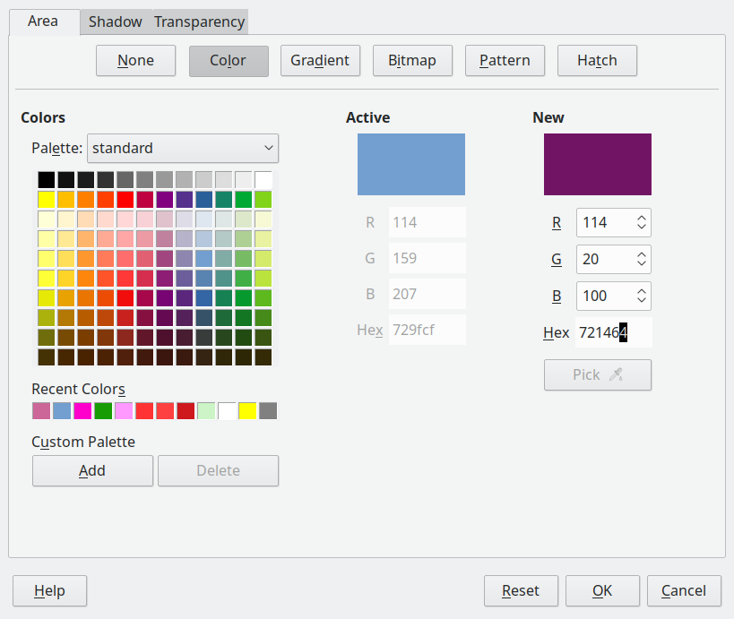

Evolving DIBs, ICM and Beyond:

Microsoft continued to refine DIBs in subsequent versions of Windows.

Windows 95/NT 4.0 introduced Image Color Management (ICM), allowing DIBs to specify precise color requirements beyond the limitations of the display device. This further enhanced color accuracy and ensured consistent visuals across different hardware configurations.

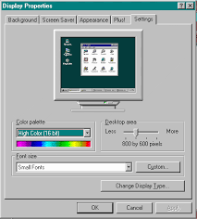

Legacy and the Modern Approach:

Despite the rise of DIBs, the older GDI bitmaps remain relevant. Understanding the concept of "bit-block transfer" and how these legacy objects interact with the GDI system is still crucial for working with bitmaps effectively.

Mastering the Bitmap Landscape:

So, how do you navigate this rich tapestry of GDI bitmap formats and functionalities?

Approaching the material chronologically, starting with basic GDI bitmaps and then progressing to DIBs and ICM, provides a strong foundation.

This historical context helps you appreciate the evolution of bitmap support and master the diverse tools available for manipulating and displaying images in Windows.

Remember, the world of GDI bitmaps is vast and rewarding to explore.

With the right knowledge and tools, you can unlock the potential to create stunning visuals, enhance user experiences, and push the boundaries of bitmap manipulation in your Windows applications.

THE BITBLT: A POWERFUL PIXEL MOVER AND MASTER OF THE VISUAL ARENA

In the realm of bitmaps, the BitBlt function reigns supreme. Pronounced "bit blit," this powerful tool stands for "bit-block transfer," and its capabilities go far beyond simply copying pixels.

Let's delve into the origins, functionality, and magic of BitBlt, your ultimate guide to manipulating and mastering the visual landscape.

From Assembly Language to Visual Revolution:

The BitBlt's story starts with the DEC PDP-10, a powerful computer of the past. In its assembly language, the BLT instruction facilitated efficient memory block transfers.

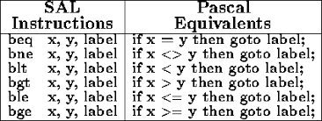

This concept of rapid movement found its way into the world of graphics through the SmallTalk system, where all graphic operations revolved around the BitBlt.

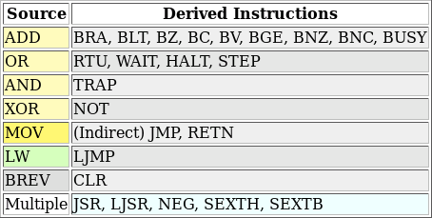

Programmers even adopted "blt" as a verb, a testament to its fundamental role in visual creation.

Beyond Transfer: A Pixel Transformer:

Calling BitBlt a mere "transfer" would be an understatement. It's not just a copy-paste tool; it's a pixel surgeon, a visual alchemist. BitBlt performs bitwise operations on pixels, allowing for a range of effects:

Simple Copying: The most common use, BitBlt can efficiently copy rectangular areas of pixels from one location to another.

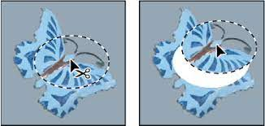

Transparency and Masking: By manipulating specific bits, you can achieve transparency, allowing underlying pixels to peek through or create intricate masks for selective blending.



Color Transformations: BitBlt can be used to alter the color palette of pixels, apply filters, and adjust brightness or contrast, transforming the visual landscape at will.

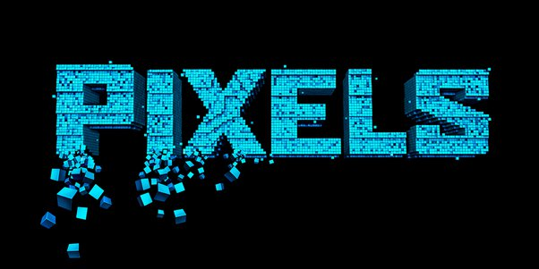

Custom Effects: With deeper understanding, you can unlock a world of creative possibilities. Imagine mirroring images, rotating them, or even blending multiple bitmaps in real-time – BitBlt makes it possible.

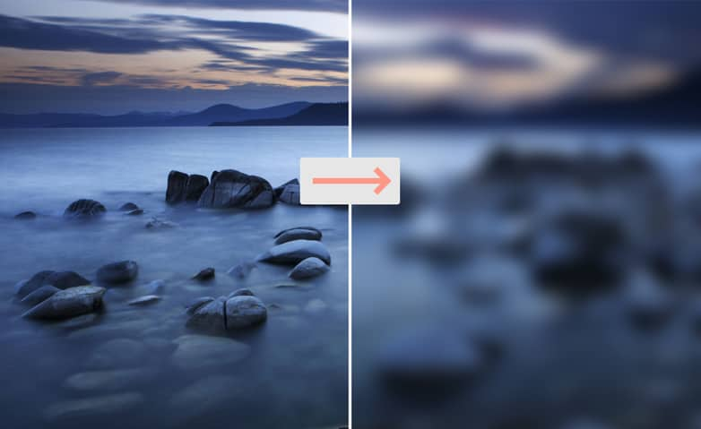

A Simple BitBlt in Action:

The BITBLT program in Figure 14-1 demonstrates a basic use case. It copies the program's system menu icon, located at the top left corner of the window, to its client area.

This simple line of code showcases the power of BitBlt – a single function call effortlessly moves a visual element within the application's window.

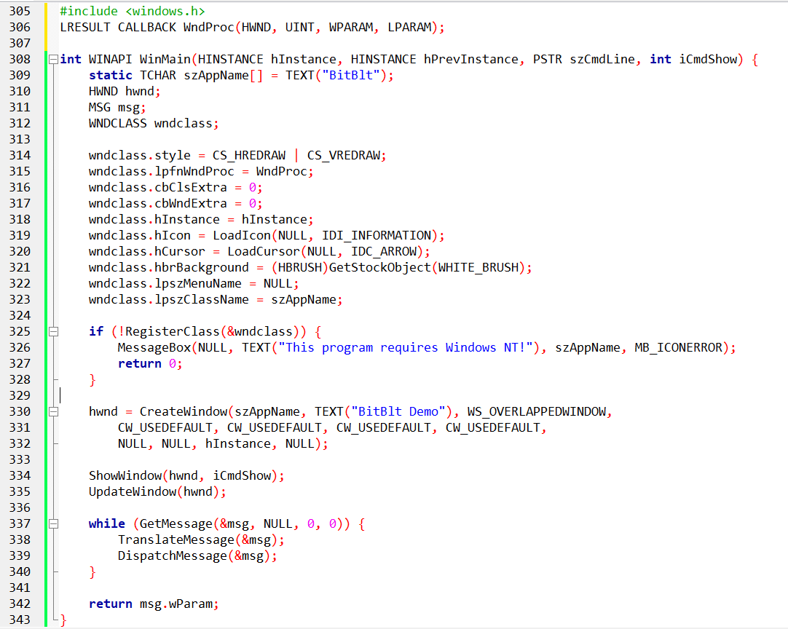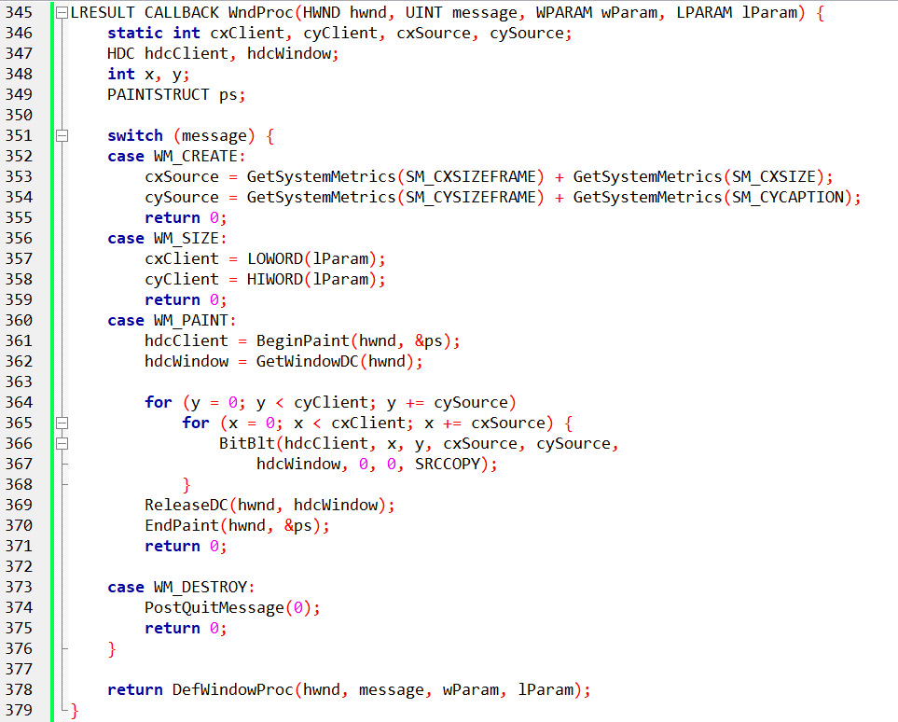

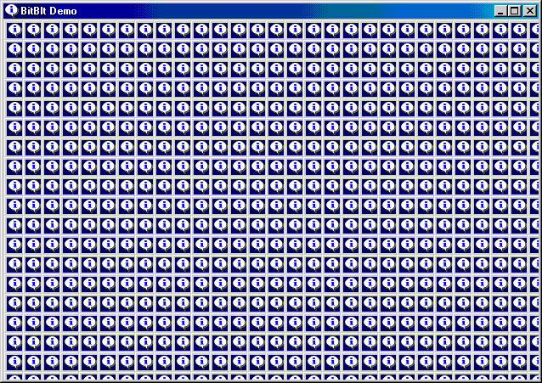

Mastering the BitBlt:

The BitBlt function offers a vast toolbox for manipulating and creating stunning visuals. To fully harness its potential, here are some key tips:

* Understand the parameters: BitBlt requires specific parameters like source and destination rectangles, color modes, and desired operations. Learning these parameters unlocks the full range of the function's capabilities.
* Explore different modes: BitBlt offers various modes like AND, XOR, and OR, each affecting how pixels are combined and transformed. Experimenting with these modes opens doors to creative effects and visual trickery.
* Combine with other tools: BitBlt is just one piece of the puzzle. Combine it with other graphical functions, drawing routines, and user interaction to create interactive and dynamic visual experiences.

The BITBLT.C code is a fascinating demonstration of the power and potential of the BitBlt function. Let's take a line-by-line tour to fully grasp its intricacies:

Header Files and Function Prototypes:

* The code includes the windows.h header file, providing access to essential Windows API functions.
* WndProc and WinMain function prototypes are declared, defining their parameters and return values.

Global Variables and Window Class Registration:

* szAppName: Stores the window's name, displayed in the title bar and used for internal references.
* hwnd: Holds the handle of the main window created by the program.
* msg: A structure containing information about Windows messages received by the program.
* wndclass: A structure defining the window class properties, including its style, window procedure, and appearance.
* RegisterClass registers the window class with the Windows system, allowing the program to create instances of the defined window type.

WinMain Function:

* Initializes the window class with desired attributes like redrawing behavior, background color, and window procedure.
* Checks for successful registration using RegisterClass. If unsuccessful, displays an error message and exits.
* Creates the main window using CreateWindow with specified title, style, and initial position.
* Shows the window using ShowWindow and updates the window content with UpdateWindow.
* Enters the main message loop, retrieving and processing messages from the system until the program exits.
* Translates and dispatches each message to the appropriate handler function.
* Finally, returns the message's wParam value upon program termination.

WndProc Function:

Handles various messages sent to the window.

* WM_CREATE: Initializes variables for source and client area sizes based on system metrics.
* WM_SIZE: Updates client area dimensions based on the window resize event.
* WM_PAINT: Performs the core BitBlt operation:
* Begins painting the window client area using BeginPaint.
* Obtains a handle to the client and window DCs (device contexts) for drawing.
* Loops through the client area in steps determined by source dimensions (cxSource, cySource).
* Inside the loop, uses BitBlt to copy a rectangular area from the window DC (source) to the client DC (destination) at specific coordinates (x, y).
* The SRCCOPY mode ensures the source pixels are directly copied to the destination.
* Releases the window DC and ends painting the client area.
* WM_DESTROY: Sends a quit message to terminate the program.
* Handles other messages like default window procedures using DefWindowProc.

Key Points to Understand:

* The program continuously copies the window content (source) to its client area (destination) using a series of BitBlt calls.
* The source dimensions are determined based on system metrics, creating a "tiled" effect within the client area.
* The loop iterates through the client area, ensuring the entire window content is copied.
* Different BitBlt modes like XOR or OR could be used for more complex visual effects.

BitBlt Syntax:

The BitBlt function transfers pixels from a source rectangle in one device context (DC) to a destination rectangle in another.

Its syntax breakdown:

* hdcDst: Handle to the destination DC (e.g., window client area)
* xDst, yDst: Coordinates of the destination rectangle's upper left corner
* cx, cy: Width and height of the rectangle to be copied
* hdcSrc: Handle to the source DC (e.g., entire window)
* xSrc, ySrc: Coordinates of the source rectangle's upper left corner
* dwROP: Raster operation (determines how pixels are combined)

Understanding the Source and Destination:

In the BITBLT program, both DCs refer to the same physical display, but their coordinate origins differ.

* hdcClient: Origin at the upper left corner of the client area
* hdcWindow: Origin at the upper left corner of the entire window

Source and Destination Positioning:

* xSrc and ySrc are set to 0, implying the entire window content is the source image.
* xDst and yDst are varied to copy the image multiple times at different positions within the client area.

Raster Operations (dwROP):

* This argument defines how source and destination pixels are blended or combined.
* The program uses SRCCOPY, which simply copies the source pixels over the destination.
* Other ROPs like XOR or OR enable various transparency and visual effects.

Important Notes:

* BitBlt transfers actual pixels from video memory, not a separate image buffer.
* Moving the window can cause incomplete image copying if part of the source falls off-screen.
* Both DCs must be compatible (either monochrome or same number of bits per pixel).

Alternative BitBlt Implementation:

* The provided code snippet demonstrates a different approach for achieving the same effect.
* It avoids repeated copying by checking if the destination point is not the upper left corner.

Further Exploration:

* Experiment with different source dimensions and loop patterns to observe how the copied content changes.
* Try modifying the BitBlt mode parameter to see how it affects the visual output.
* Combine BitBlt with other drawing functions like lines or rectangles to create more intricate visuals.

The BitBlt is more than just a function; it's a gateway to a world of visual possibilities. By understanding its origins, exploring its capabilities, and practicing its application, you can unlock the power to manipulate, transform, and create stunning visuals within your Windows applications. So, grab your pixel brush, embrace the BitBlt, and start painting your own masterpiece on the digital canvas!

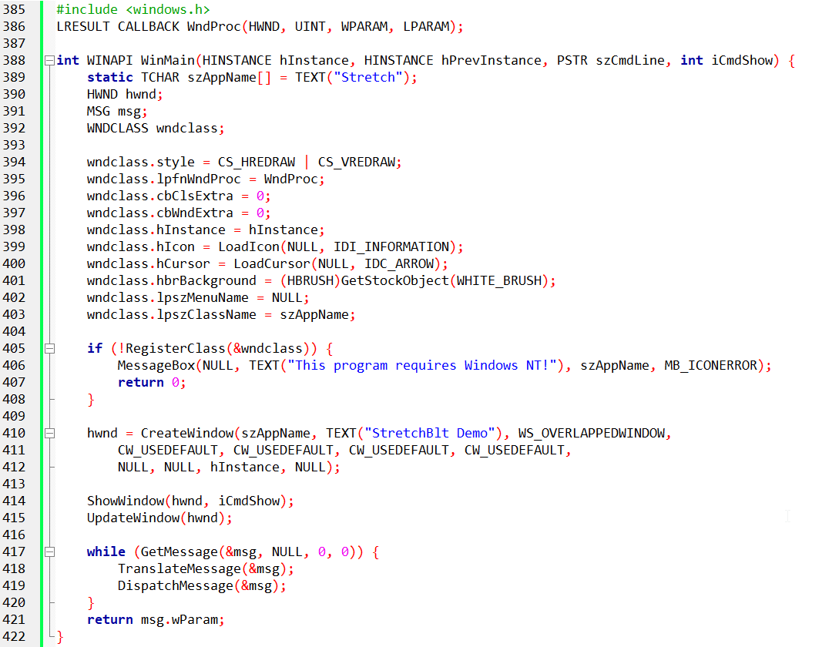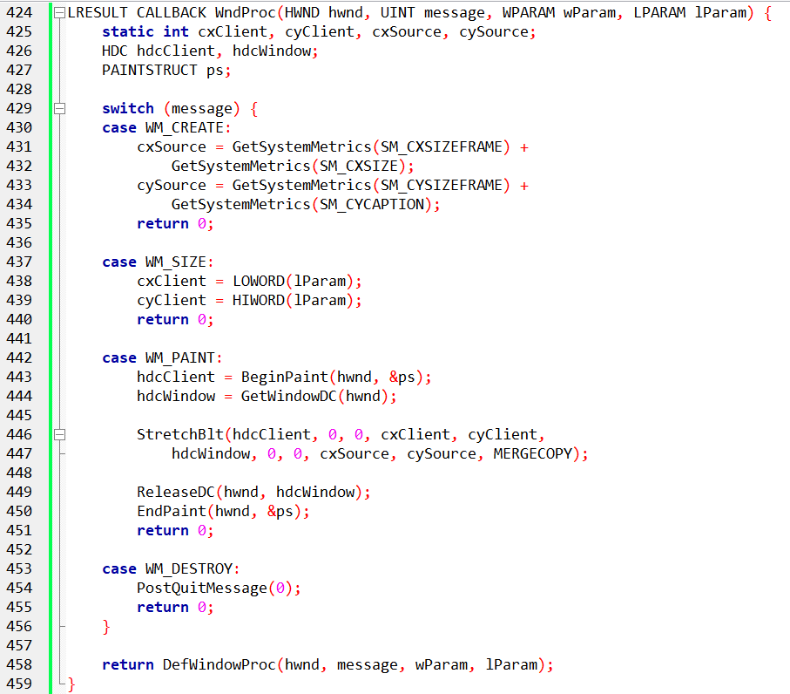

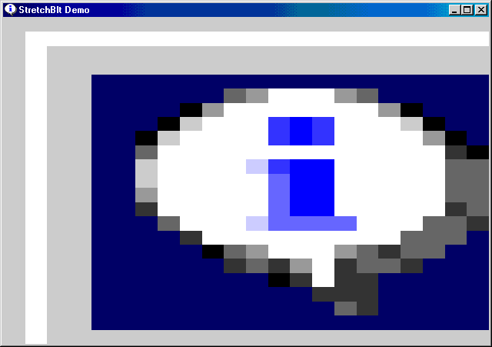

MASTERING THE STRETCHBLT FUNCTION: STRETCHING AND COMPRESSING IMAGES WITH POWER

The BitBlt function, while powerful, limits you to copying images of the same size. But what if you want to stretch or compress an image while copying it? Enter StretchBlt, a versatile tool for manipulating image dimensions on the fly. Let's delve deep into its syntax and operation, inspired by the STRETCH program:

StretchBlt Syntax Breakdown:

hdcDst, xDst, yDst, cxDst, cyDst: Destination device context handle, coordinates of the destination rectangle's upper left corner, and desired width and height of the destination rectangle.

hdcSrc, xSrc, ySrc, cxSrc, cySrc: Source device context handle, coordinates of the source rectangle's upper left corner, and original width and height of the source image.

dwROP: Raster operation code, defining how source and destination pixels are combined (e.g., MERGECOPY for smooth blending).

STRETCH Program Analysis:

The program uses StretchBlt only once, but it fills the entire client area with the system menu icon.

The destination rectangle (cxClient, cyClient) spans the entire client area, stretching the source image to fit.

The source rectangle (cxSource, cySource) represents the original size of the system menu icon.

MERGECOPY as the ROP ensures smooth blending of pixels during the stretch.

Understanding the Stretch:

StretchBlt scales the source image to fit the specified destination dimensions.

It can stretch or compress the image proportionally or non-proportionally depending on the chosen destination rectangle.

Imagine stretching a rubber sheet – the image content gets warped and distorted as the dimensions change.

Beyond the Basics:

Experiment with different destination rectangle sizes to see how the image stretches or compresses.

Try other ROPs like SRCCOPY (simple copying) or XOR (transparent blending) to observe different visual effects.

Combine StretchBlt with other drawing functions to create visually complex compositions.

StretchBlt Advantages:

Offers flexibility in manipulating image size during copying.

Enables creative effects like stretching backgrounds or zooming into images.

Provides a powerful tool for building interactive user interfaces with dynamic visuals.

Limitations to Remember:

Stretching can distort or blur the image, impacting quality.

Scaling beyond certain limits might lead to unwanted artifacts or pixelation.

Be mindful of compatibility between source and destination DCs.

Stretching Your Horizons:

Mastering StretchBlt unlocks a world of possibilities for manipulating and presenting images in your Windows applications. Remember:

* Practice with different parameters and ROPs to unlock creative visual potential.
* Be mindful of potential quality loss when stretching images.
* Combine StretchBlt with other tools and techniques for a richer visual experience.

DIVING INTO THE DEPTHS OF MAPPING MODES AND BITBLT: A JOURNEY BEYOND PIXELS

While BitBlt and StretchBlt offer powerful tools for image manipulation, their true complexity lies beneath the surface, in the realm of mapping modes and their impact on coordinate interpretation. Let's take a deep dive into this intricate world, inspired by the provided text:

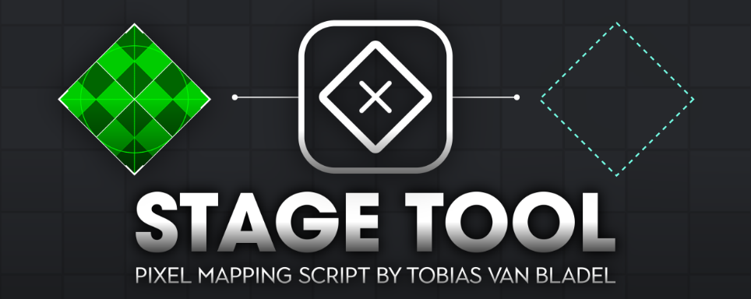

Mapping Modes: Pixels vs. Logic

BitBlt and StretchBlt operate in logical units, independent of the underlying physical device.

But what happens when different mapping modes are applied to the same device in a single BitBlt call?

This creates ambiguity, as the cx and cy arguments (logical units) apply to both source and destination rectangles.

Conversion to Device Coordinates:

Before the actual bit transfer, all coordinates and sizes need conversion to device-specific units (pixels).

This conversion happens separately for both source and destination DCs to account for potential mapping mode differences.

Same Mapping Mode, Same Size:

When both DCs share the same mapping mode (e.g., MM_TEXT) or are the same DC, the converted sizes in pixels will be identical.

This allows Windows to perform a simple pixel-to-pixel transfer.

Mapping Mode Mismatch: Enter StretchBlt

When the converted rectangle sizes differ between DCs, Windows steps in with the versatile StretchBlt function.

StretchBlt handles the scaling and transformation necessary to bridge the gap between logical units and device-specific pixels.

Flipping and Mirroring with StretchBlt:

StretchBlt offers additional capabilities like flipping images horizontally or vertically.

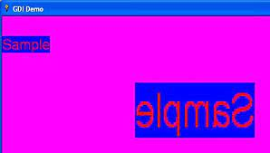

This depends on the signs of cxSrc, cxDst, cySrc, and cyDst after conversion to device units.

Changing signs in STRETCH program demonstrates this:

xDst = cxClient, cxDst = -cxClient: Creates a mirror image (left becomes right and vice versa).

yDst = cyClient, cyDst = -cyClient: Turns the image upside down.

Key Takeaways:

* Mapping modes add complexity to BitBlt and StretchBlt.
* Understanding these conversions and their impact on coordinate interpretation is crucial for accurate image manipulation.
* StretchBlt shines when mapping modes differ, providing scaling and transformation capabilities.
* Experimenting with StretchBlt parameters like signs of width and height unlocks creative effects like flipping and mirroring.

Remember:

Mastering mapping modes and their interplay with BitBlt and StretchBlt empowers you to manipulate images with precision and control.

Don't hesitate to experiment and explore different scenarios to unlock the full potential of these versatile functions.

MASTERING THE STRETCHBLT MODE: AVOIDING DISTORTION AND CHOOSING THE RIGHT BLEND

Stretching an image with BitBlt can be a tricky business, and understanding the different stretching modes is key to achieving the best results. Let's dive deeper into this topic:

The Challenges of Scaling:

Enlarging or shrinking an image inevitably involves duplicating or combining pixels. When this process isn't precise (e.g., non-integer scaling factors), distortions can creep in, making the image blurry or pixelated.

Stretching Modes: Shaping the Outcome:

To address these challenges, StretchBlt offers different modes that determine how pixels are combined during scaling. Choosing the right mode can significantly impact the final visual quality:

1. BLACKONWHITE/STRETCH_ANDSCANS (Default):

This mode uses a logical AND operation, favoring black pixels. If any original pixel is black, the resulting pixel will be black.

Ideal for monochrome images where black dominates on a white background.

Can lead to unwanted black artifacts in color images or images with significant white areas.

2. WHITEONBLACK/STRETCH_ORSCANS:

This mode uses a logical OR operation, favoring white pixels. Only if all original pixels are black will the resulting pixel be black.

Good for monochrome images with white dominating on a black background.

Can make bright areas in color images appear washed out.

3. COLORONCOLOR/STRETCH_DELETESCANS:

This mode simply discards rows or columns of pixels without any blending.

Often the best choice for color images, as it preserves the original color palette and avoids unwanted blending artifacts.

Can lead to visible gaps or jagged edges if the scaling factor is large.

4. HALFTONE/STRETCH_HALFTONE:

This mode calculates an average color based on the source pixels being combined.

Used in conjunction with a halftone palette for a specific visual effect (discussed in Chapter 16).

Not widely used in general image scaling scenarios.

Choosing the Right Mode:

The best stretching mode depends on your specific image and desired outcome:

* Monochrome images: Choose BLACKONWHITE for black-on-white or WHITEONBLACK for white-on-black.
* Color images: Opt for COLORONCOLOR to avoid unwanted blending artifacts.
* Specific visual effects: Explore HALFTONE in conjunction with a halftone palette for unique results.

Additional Tips:

Experiment with different modes and scaling factors to see how they impact the image.

Consider using antialiasing techniques to smooth out edges and reduce pixelation.

Remember, the chosen mode is just one factor in achieving high-quality image scaling.

DEEP DIVE INTO RASTER OPERATIONS: UNLOCKING THE SECRETS OF BITBLT AND STRETCHBLT

While BitBlt and StretchBlt seem like simple image copying functions, they hide a powerful secret: raster operations. These operations allow you to manipulate and combine images in intricate ways, transforming your pixels into visual magic. Let's delve into the fascinating world of raster operations, inspired by the provided text:

Beyond Simple Copying:

BitBlt and StretchBlt don't just transfer bits; they perform a three-way dance between:

* Source: The image being copied, stretched, or compressed to fit the destination.
* Destination: The existing content on the target area before the operation.
* Pattern: The brush currently selected in the destination device context, tiled to fit the destination area.

The Power of 256:

This three-way interaction creates a whopping 256 possibilities for how pixels are combined! Each combination defines a unique raster operation (ROP) code.

Understanding the ROP Table:

The table provided breaks down 15 named ROPs, offering a glimpse into their logic. Each row represents a specific operation, and each column represents the state of a pixel in the final result.

Imagine each cell as a light switch:

* 1 - Light on (pixel is present)
* 0 - Light off (pixel is missing)

Examining the Logic:

* Look at the BLACKNESS operation: all destination pixels become off (0s), regardless of source and pattern.
* In NOTSRCCOPY, source pixels are flipped (1s become 0s and vice versa), then combined with the destination using a logical AND. This inverts the source image colors.
* SRCERASE erases the source pixels from the destination using a logical NOT. Existing pixels remain untouched.

Unlocking Creative Potential:

These are just a few examples! Experiment with different ROPs to see how they blend, mask, and transform images.

Try MERGECOPY for a smooth blend between source and destination, or PATINVERT for a funky pixelated effect.

Beyond the Names:

The table only shows 15 named ROPs. The remaining 241 have numeric codes for more advanced operations.

Don't be afraid to explore these codes and their possibilities! Research and experiment to push the boundaries of what you can achieve with raster operations.

Remember:

The ROP table is your key to unlocking the full potential of BitBlt and StretchBlt.

By understanding how these operations combine source, destination, and pattern, you can create stunning visual effects and manipulate images in ways you never imagined before.

So, grab your pixels, dive into the world of ROPs, and let your creativity flow!

*Below is just a small version of the table of 256 entries…ROP table has a lot of entries.*

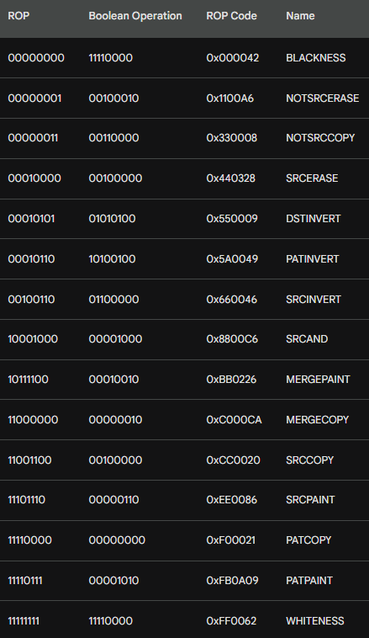

Understanding Raster Operations: A Deep Dive

This table unlocks the mysteries of raster operations, powerful tools for manipulating images on your screen. Let's dissect it layer by layer:

ROP Code: This is the numeric key that tells the BitBlt or StretchBlt functions what to do with the source, destination, and pattern bitmaps. Think of it as a secret code for image manipulation.

Name: Each code has a human-readable name, like "BLACKNESS" or "PATCOPY," giving you a hint about its purpose.

Bitwise Operation: This column shows the actual mathematical logic behind each operation, using bitwise AND, OR, XOR, and NOT operations on the source, destination, and pattern bits.

Boolean Operation: This simplifies the bitwise logic using familiar C syntax like S & ~D (Source AND NOT Destination).

Monochrome Example: Imagine a black and white world, where 0 is black and 1 is white. This helps visualize how each operation affects the resulting image.

PATCOPY: This operation simply copies the pattern to the destination, ignoring the existing pixels. Think of it like a digital stamp!

PATPAINT: This is a bit trickier. It paints the destination based on the pattern and the existing pixels, with interesting twists:

* A black source pixel always produces white (remember, 0 = black, 1 = white).
* The destination becomes black only if the source is white and both the pattern and the destination are black.

Color Displays: For color displays, each pixel has multiple bits, each representing a different color component (red, green, blue, etc.). The operations are performed on each bit individually, allowing for fascinating color combinations.

Palette Magic: The final color displayed depends on how the video board's palette is set up. Windows tries to make things predictable, but changing the palette can lead to surprising results!

Nonrectangular Images: This chapter explores how these operations can be used for creative effects beyond simple rectangles, opening up new possibilities for image manipulation.

Key takeaways:

* Understanding the ROP codes and their bitwise logic empowers you to manipulate images with precision.
* Think of the pattern as a digital stencil, the source as a color source, and the destination as the canvas.
* Remember, color displays add a layer of complexity due to the interplay of multiple color bits and the video board's palette.

PATBLT: THE SIMPLEST BRUSH FOR YOUR CANVAS

Windows offers a trio of powerful tools for image manipulation: BitBlt, StretchBlt, and the streamlined PatBlt. Unlike its siblings, PatBlt requires only a destination device context, making it a breeze to use.

Here's how to wield this brush:



Parameters:

* hdc: Handle to the destination device context (where you'll paint)
* x, y: Coordinates of the rectangle's upper left corner (logical units)
* cx, cy: Width and height of the rectangle (logical units)
* dwROP: Integer specifying the desired raster operation (ROP code)

What it does:

PatBlt applies a chosen ROP code to the specified rectangle within the destination context. Think of it as choosing a brush (the ROP code) and painting a designated area (the rectangle) on your digital canvas.

ROP codes for PatBlt:

Remember, PatBlt only works with a subset of ROP codes that don't involve source context. Here's a sneak peek at its 16 available operations:

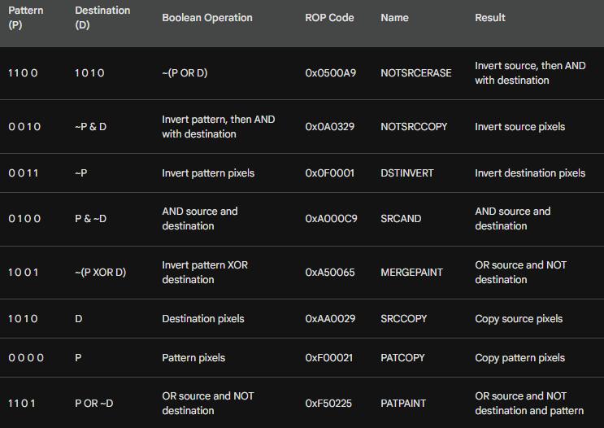

Ready to paint?

This table provides a starting point for exploring PatBlt's capabilities. Remember, each ROP code represents a unique way to manipulate the pixels within your chosen rectangle. Experiment and see what creative effects you can achieve with this versatile brush!

Bonus Tip: For a deeper understanding of each ROP code, refer back to the complete table discussed earlier. There, you'll find detailed explanations of the bitwise operations and their impact on the resulting image.

Happy painting!

PatBlt: Your Handy Tool for Rectangle Magic

PatBlt, a powerful brush in the Windows GDI toolbox, lets you paint rectangles with ease. Here's a rundown of some common uses:

Black and White Magic:

Black Rectangle: PatBlt (hdc, x, y, cx, cy, BLACKNESS); - This code fills the specified rectangle with pure black. Think of it as a digital eraser!

White Rectangle: PatBlt (hdc, x, y, cx, cy, WHITENESS); - This code paints the rectangle with a brilliant white, like a fresh coat of digital paint.

Inversion Power:

Invert Rectangle: PatBlt (hdc, x, y, cx, cy, DSTINVERT); - This handy trick flips the colors of the specified rectangle. Pixels that were black turn white, and vice versa.

Invert with White Brush: PatBlt (hdc, x, y, cx, cy, PATINVERT); - This code works similarly to DSTINVERT, but only if you have a white brush selected in the device context. It's like having a double-sided coin for inverting!

Behind the Scenes:

FillRect Demystified: Did you know FillRect, which fills rectangles with your chosen brush, is actually built on PatBlt? This code shows how:



InvertRect Explained: Calling InvertRect on a rectangle actually translates into a PatBlt call with DSTINVERT! It's like a secret handshake between Windows functions.

Coordinate Corner:

PatBlt uses a slightly different coordinate system than other GDI functions. While for most functions, (x, y) represents the upper left corner, for PatBlt, it can be either the upper left or the lower left, depending on the mapping mode and the signs of cx and cy. Remember, the key is to think of the rectangle defined by two corners: (x, y) and (x + cx, y + cy).

Painting Precisely with PatBlt: Mapping Modes and Parameters

PatBlt, your trusty GDI brush, shines even brighter when you understand its relationship with different mapping modes. Let's take a closer look at how to paint a square inch at the upper left corner of the client area in MM_LOENGLISH mode:

The Magic of Coordinates:

* x and y: Think of them as the anchor points of your rectangle. They define the upper left corner in most cases.
* cx and cy: These determine the width and height of the rectangle, but with a twist. Their absolute values represent the width and height, and their signs influence the rectangle's position.

Mapping Modes and PatBlt Parameters:

* MM_LOENGLISH: In this mode, y values increase as you move up the screen, and x values increase to the right. This means:
* Negative cy: Use it to paint rectangles above the specified point (y).
* Positive cx: Use it to paint rectangles to the right of the specified point (x).

Painting Your Square Inch:

Here are four valid ways to paint a one-inch square at the upper left corner of the client area using PatBlt:

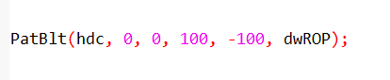

This sets the upper left corner at (0, 0), uses a width of 100, and a negative height of -100 to paint above the point.

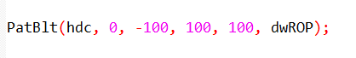

This again uses (0, -100) as the upper left corner, with a width of 100 and a positive height to paint below the point.

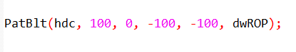

This shifts the rectangle to the right by setting (100, 0) as the upper left corner, then uses negative values for both width and height to paint a square inch within the bounding box.

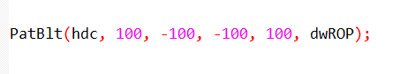

This combines the rightward shift with the previous approach, placing the upper left corner at (100, -100) and using negative width and positive height to paint the square inch.

Remember:

* Always use the mapping mode's coordinate rules to determine the signs of cx and cy for accurate rectangle positioning.
* Experiment with different values to see how PatBlt interacts with your chosen mapping mode.

MAPPING MODES: YOUR GUIDE TO PRECISE PATBLT PAINTING

Understanding mapping modes is key to wielding PatBlt, your GDI brush, with precision. Here's a quick guide to some common modes and their impact on PatBlt parameters:

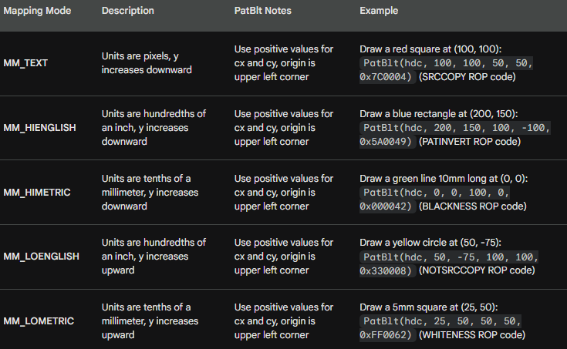

Remember:

* This is just a glimpse into the diverse world of mapping modes. Windows offers many more options with unique properties.
* Always refer to the official documentation for detailed information on each mode and its impact on GDI functions like PatBlt.
* Experimenting with different modes and parameters is the best way to deepen your understanding and unlock their creative potential.

GDI BITMAP OBJECT

DDB vs. DIB: Demystifying the Windows Bitmap Duo

In the world of Windows graphics, two bitmaps reign supreme: the Device-Independent Bitmap (DIB) and the Device-Dependent Bitmap (DDB). Though their names might sound similar, their roles and relationships are often misunderstood. Let's clear the confusion and unveil their true identities:

DDB: The Veteran Performer

Windows has known DDBs since its early days, making them the seasoned veterans of the bitmap scene. They're tightly coupled with specific display devices, meaning their performance excels when working directly with that hardware. Think of them as the specialized tools that get the job done quickly and efficiently on their designated platform.

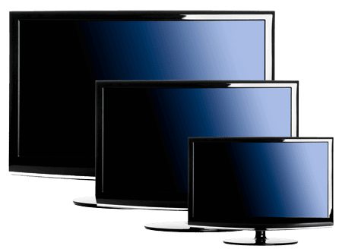

DIB: The Versatile Traveler

DIBs, introduced in Windows 3.0, are the adaptable newcomers. They carry their visual data independently of any specific device, making them the ultimate digital nomads. This freedom allows them to roam across different platforms and environments without losing their information. However, their versatility often comes at a cost: processing them might not be as speedy as with DDBs.

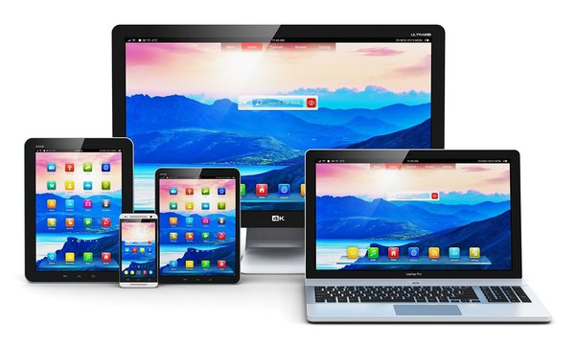

The Bridge Between Worlds:

While distinct, DDBs and DIBs aren't isolated entities. They can be converted into each other, acting as bridges between their respective worlds.

DIBs can be translated into DDBs for optimized performance on a specific device, while DDBs can be transformed into DIBs for platform-independent sharing and manipulation.

Why Both Matter:

Assuming DIBs have rendered DDBs obsolete would be a mistake. Both types of bitmaps have their strengths:

DDBs for Performance: When speed is crucial and you're working directly with a specific device, DDBs are the champions. Their close ties to the hardware make them incredibly efficient for tasks like direct screen manipulation.



DIBs for Flexibility: Need to share or process your image data across different platforms? DIBs are your go-to choice. Their device-independence makes them adaptable and versatile, allowing you to work with your images without limitations.

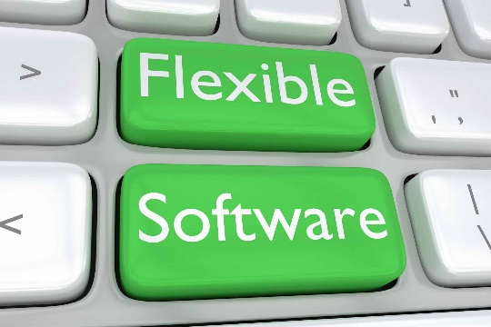

The Bottom Line:

Understanding the differences and complementary nature of DDBs and DIBs is key for Windows graphics mastery.

Choose the right tool for the right job: DDBs for device-specific speed, DIBs for platform-independent flexibility.

Remember, both have their place in the bitmap kingdom, and knowing when to wield each one is the true mark of a Windows graphics expert.

Don't be afraid to experiment! Convert between DDBs and DIBs to see how they interact and how each type can benefit your specific needs. The more you explore, the deeper your understanding of these powerful bitmap tools will become.

DEMYSTIFYING DDB CREATION: A DEEP DIVE WITH CODE EXAMPLES

Windows GDI offers a powerful tool for creating custom bitmaps: the Device-Dependent Bitmap (DDB). This guide delves into the intricacies of creating DDBs, from parameter explanations to code examples.

DDB Creation Functions:

Three primary functions handle DDB creation:

CreateBitmap: This versatile function allows specifying width, height, color planes, and bits per pixel (bpp). The bits parameter can be set to NULL to leave the initial pixel data blank.



CreateCompatibleBitmap: This simplifies DDB creation for compatibility with a specific device context (hdc). It automatically retrieves the required parameters from the device context.



CreateBitmapIndirect: This function takes a pre-filled BITMAP structure as input, offering precise control over DDB properties. Use the bmBits field to initialize pixel data.

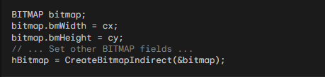

Parameter Breakdown:

* cx, cy: Width and height of the DDB in pixels.
* cPlanes: Number of color planes (typically 1 for monochrome, 4 for CMYK).
* cBitsPixel: Number of bits per pixel (1 for monochrome, 8 for typical RGB).
* bits: Pointer to an array of initial pixel data (optional).
* hdc: Handle to the device context for compatible bitmap creation.
* bitmap: A pre-filled BITMAP structure defining DDB properties.

Destroying DDBs: Once you're done using a DDB, it's crucial to destroy it to release the allocated memory and prevent memory leaks. This can be done with the DeleteObject function:



Calling this function with the handle to the DDB will release the memory associated with it, ensuring efficient resource management within your program. Remember, neglecting to delete DDBs can lead to memory leaks and performance issues in your application.

Importance of Resource Management:

Proper resource management is essential for any Windows application. By destroying DDBs when no longer needed, you ensure:

* Reduced memory usage: This prevents memory leaks and improves overall system performance.
* Efficient resource allocation: Unused DDBs can be released for other applications or system tasks.
* Stable and reliable program execution: Avoiding memory leaks contributes to a more robust and stable application.

Memory Allocation and Padding:

Windows allocates memory for the DDB based on its dimensions, but with some padding:

* Each row of pixels has an even number of bytes (padding with zeros if needed).
* The total allocated memory is cy * cPlanes * ((cx * cBitsPixel + 15) / 16).

Practical Considerations:

* In most cases, you'll use CreateCompatibleBitmap for efficient DDB creation matching the target device.
* CreateBitmap offers flexibility for custom bitmaps, but be mindful of valid parameter combinations.
* Use BITMAP structures for detailed DDB configuration via CreateBitmapIndirect or GetObject (retrieves DDB information).
* Remember to destroy created DDBs with DeleteObject to avoid memory leaks.
* Bonus Tip: Experiment with different DDB parameters and creation methods to understand their impact on memory usage and compatibility.

Remember:

This guide provides a comprehensive overview of DDB creation. For detailed parameter descriptions and advanced techniques, refer to the official Windows GDI documentation.

By mastering the art of DDB creation, you unlock a powerful tool for manipulating visuals in your Windows applications.

BITMAP BITS IN DDBS: A DEEP DIVE

DDBs, the workhorses of GDI, offer flexibility in managing pixel data. This section dives deep into the realm of bitmap bits, exploring their manipulation and the crucial concept of device dependence.

Setting and Getting Pixel Bits:

DDBs can be created with initial pixel data or remain uninitialized. Two functions handle bit manipulation:

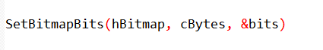

This function allows you to replace existing pixel data or initialize a new DDB with your desired bit pattern. cBytes specifies the number of bytes to copy, and bits is a pointer to the source buffer containing the pixel data.

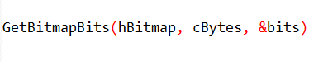

This function retrieves a copy of the existing pixel data from a DDB into the provided buffer pointed to by bits.

Understanding Bit Arrangement:

Pixel bits are arranged starting from the top row, adhering to a crucial rule: each row must have an even number of bytes.

Monochrome DDBs (1 plane, 1 bit per pixel) have simple bit values: 1 represents the "on" state and 0 the "off" state.

Non-monochrome DDBs (multiple planes or bits per pixel) are more complex. Their pixel values directly influence the displayed color, but without referencing a fixed color table.

Device Dependence and Palette Lookups:

The displayed color of a non-monochrome DDB pixel relies on the device's specific palette lookup table (PLT).

The pixel value acts as an index into this table to determine the actual RGB color displayed on the screen. This dependency on the device's PLT makes non-monochrome DDBs highly device-specific, limiting their portability and predictability.

Practical Takeaways:

Monochrome DDBs: Setting pixel bits directly using SetBitmapBits is straightforward and effective.

Non-monochrome DDBs: Avoid relying on interpreting pixel values directly. Use them as an abstract representation of color for device-specific drawing operations.

Newer Alternatives: SetDIBits and GetDIBits offer greater flexibility and device independence for color DDB manipulation. We'll explore them in the next chapter.

Additional Functions:

SetBitmapDimensionEx/GetBitmapDimensionEx: These functions allow setting and retrieving a bitmap's dimensions in 0.1 mm units. This information serves as a tag for associating metrical data with a DDB, but it has no direct impact on drawing or display.

* Understand the concept of device dependence when dealing with non-monochrome DDBs.
* Leverage SetBitmapBits and GetBitmapBits cautiously, mainly for monochrome DDBs.
* Consider SetDIBits and GetDIBits for more versatile color DDB manipulation in future chapters.

MEMORY DEVICE CONTEXT

The memory device context (MDC) is a crucial element in GDI, serving as a virtual canvas for drawing operations before displaying them on the actual screen. Understanding its role and interaction with DDBs is essential for mastering GDI techniques.

What is an MDC?

Unlike a regular device context (DC) associated with a physical device like a screen or printer, an MDC exists solely in memory.

It acts as a "compatible" counterpart to a real DC, inheriting its properties but offering a flexible drawing space decoupled from the physical output device.

Creating an MDC:

*Creating an MDC involves two primary methods:*

Using CreateCompatibleDC: This function takes a handle to a real DC (e.g., the video display DC) and creates an MDC compatible with its parameters. This ensures your drawings in the MDC will translate smoothly to the target device.



Using NULL with CreateCompatibleDC: This shortcut creates an MDC compatible with the video display DC, making it ideal for general drawing tasks without specifying a specific real device.

Selecting a DDB:

An MDC's display surface is initially tiny (1x1 pixel), limiting its usefulness. To unlock its potential, you need to select a GDI bitmap object (DDB) into it using SelectObject:



This essentially assigns the DDB as the MDC's drawing canvas, allowing you to draw on the bitmap's surface. However, remember that:

Only compatible DDBs can be selected. The DDB's color planes and bits per pixel must match the MDC's compatibility settings.

Bizarre DDBs (e.g., 5 planes, 3 bpp) won't work due to incompatibility issues.

MDC's Power and Potential:

Once a DDB is selected, the MDC becomes a powerful tool for off-screen drawing:

* You can use GDI drawing functions to manipulate the bitmap directly, creating complex visuals without affecting the screen until you're ready.
* You can leverage BitBlt to transfer drawn content from the MDC to the real DC, effectively displaying your off-screen artwork on the actual screen.
* Conversely, you can use BitBlt to capture a portion of the screen into a bitmap using the MDC as a temporary storage container.

Key Takeaways:

* MDCs provide a flexible drawing space independent of the physical output device.
* Create MDCs compatible with specific devices or the video display using CreateCompatibleDC.
* Select compatible DDBs into the MDC to create a drawing canvas.
* Leverage MDCs for off-screen drawing and manipulation before displaying the final results.
* Master BitBlt to transfer content between MDCs and real DCs for versatile drawing and screen capture.

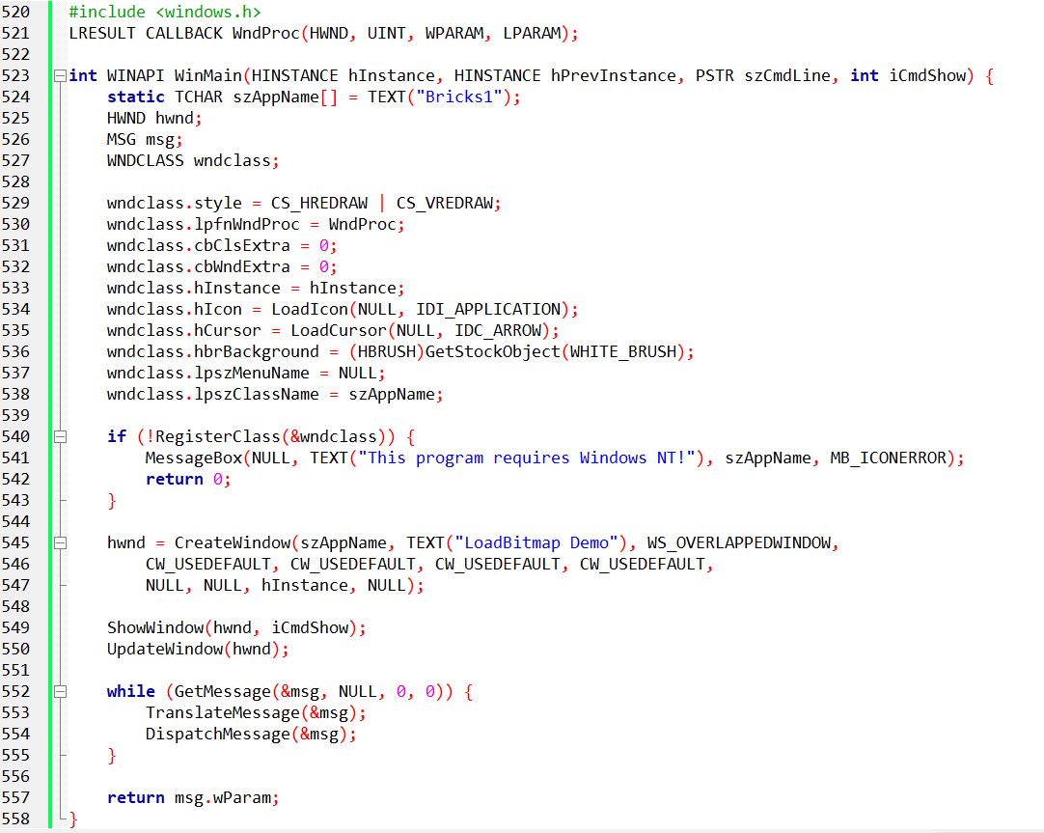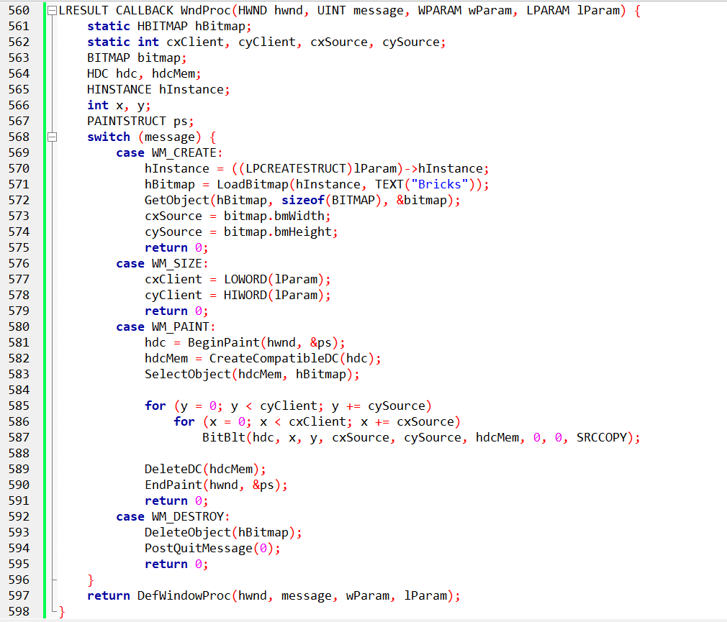

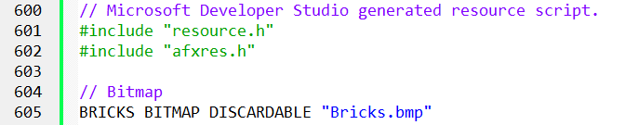



BRICKS.BMP IN BRICKS1.C

The BRICKS.BMP file plays a crucial role in the BRICKS1.C program, serving as the source of the repeating brick pattern displayed on the window. Let's delve deeper into its purpose and how it interacts with the code:

Resource Definition:

BRICKS BITMAP DISCARDABLE "Bricks.bmp": This line in the BRICKS1.RC file defines a resource called BRICKS of type BITMAP.

DISCARDABLE: This keyword indicates that the resource can be unloaded from memory when not needed, potentially improving memory management.

"Bricks.bmp": This path points to the actual bitmap file location, which should be within the project directory or a specific resource folder.

Loading and Using the Bitmap:

LoadBitmap: In the WM_CREATE case of the WndProc function, the line hBitmap = LoadBitmap(hInstance, TEXT("Bricks")) retrieves the BRICKS resource using its name. This function returns a handle for the loaded bitmap object.

GetObject: To obtain information about the bitmap, the program uses GetObject(hBitmap, sizeof(BITMAP), &bitmap) in the same case. This fills the bitmap structure with details like width, height, and color planes.

BitBlt: In the WM_PAINT case, the program uses BitBlt to repeatedly copy the BRICKS bitmap onto the window surface. The loop iterates through the entire client area, tiling the bitmap horizontally and vertically to create the brick wall effect.

Key Points:

* BRICKS.BMP provides the source data for the brick pattern.
* LoadBitmap loads the bitmap resource into memory and returns a handle for accessing it.
* GetObject gathers information about the bitmap's dimensions and format.
* BitBlt efficiently copies the bitmap onto the window at various positions, creating the repeating pattern.

Additional Notes:

* The resource definition allows discarding the bitmap when not in use, potentially optimizing memory usage.
* The program ensures proper cleanup by deleting the bitmap handle in the WM_DESTROY case.

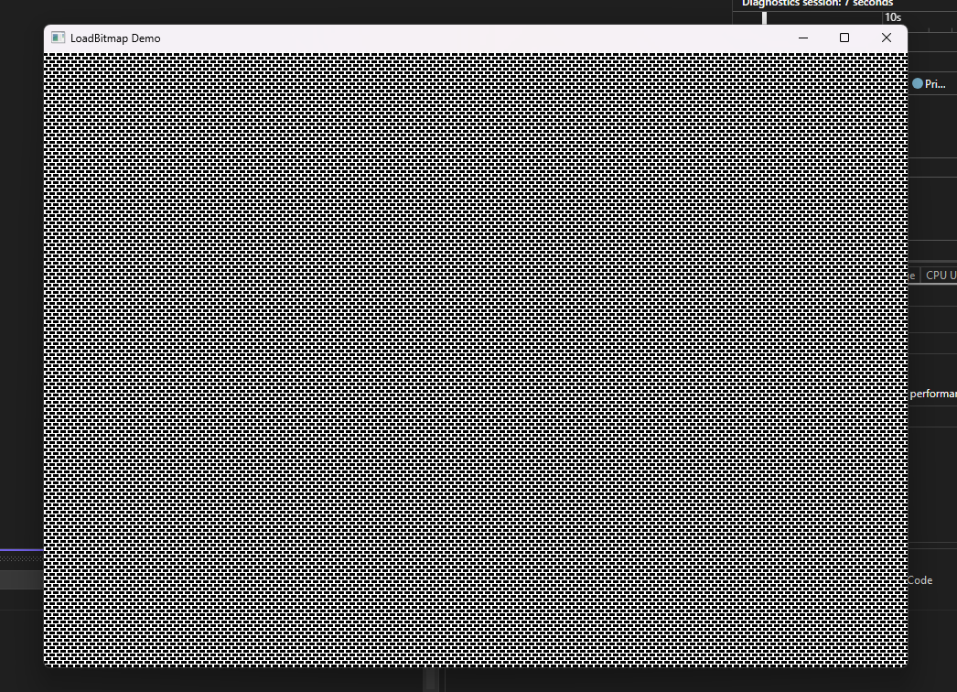

MONOCHROME BITMAP CREATION

BRICKS2.C introduces a fascinating alternative to resource-based bitmap creation: directly defining monochrome bitmaps within your program. This section dives deep into this technique, explaining its advantages and the process involved.

The Power of Direct Monochrome Bitmap Creation:

For small, monochrome images, resource creation can be unnecessary overhead. BRICKS2.C showcases the power of directly defining the bit pattern within the code, offering several benefits:

* Simplified workflow: Eliminates the need for separate resource files and loading procedures.
* Greater control: You have direct access to every bit, allowing precise manipulation of the pixel pattern.
* Enhanced flexibility: Changes to the image can be easily implemented by modifying the bit sequence within your code.

Understanding the Monochrome Format:

As demonstrated in the example, monochrome bitmaps are essentially binary grids where:

* 0 represents black pixels.
* 1 represents white pixels.

By reading these bits from left to right and grouping them into 8-bit sequences, you create the byte data for the bitmap. Padding with zeros ensures an even number of bytes if the width isn't a multiple of 16.

Constructing the BITMAP Structure and Byte Array:

The example provides the code for setting up the BITMAP structure and the BYTE array containing the bitmap data:

* BITMAP structure: This defines key parameters like width, height, and byte width.
* BYTE array: This stores the actual bit sequence in byte format.

Creating the Bitmap:

Three approaches are presented for creating the bitmap object:

* CreateBitmapIndirect with bmBits: This method directly assigns the byte array to the bmBits field of the BITMAP structure and then creates the bitmap.
* CreateBitmapIndirect followed by SetBitmapBits: This separates the creation and data assignment steps, allowing flexibility for modifying the bit data later.
* CreateBitmap with all parameters: This one-line approach combines defining the BITMAP structure and assigning the byte data in a single step.

BRICKS2.C IN ACTION:

The BRICKS2 program leverages direct monochrome bitmap creation to display a repeating brick pattern without relying on a resource file. This highlights the potential for creating simple visuals directly within your code.

Key Takeaways:

* Direct monochrome bitmap creation offers a flexible and efficient alternative to resource-based approaches.
* Understanding the binary format and constructing the necessary structures empowers you to define your own bit patterns.
* BRICKS2.C demonstrates the practical application of this technique, showcasing its potential for creating custom visuals.

Remember:

* This approach is most effective for small, monochrome images.
* Experimentation and exploration are key to mastering this technique and pushing its creative boundaries.
* Feel free to ask any further questions you may have about monochrome bitmaps, their creation process, or specific aspects of BRICKS2.C! I'm here to support your journey into the world of efficient and direct bitmap manipulation.

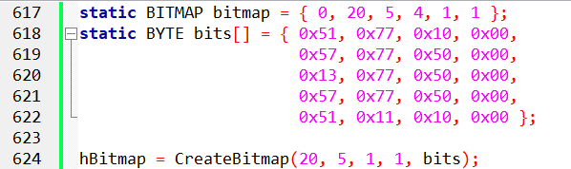

This code sets up a BITMAP structure with the specified dimensions and initializes a BYTE array with the corresponding monochrome bits.

The CreateBitmap function is then used to create the monochrome bitmap directly with the provided dimensions and bit data.

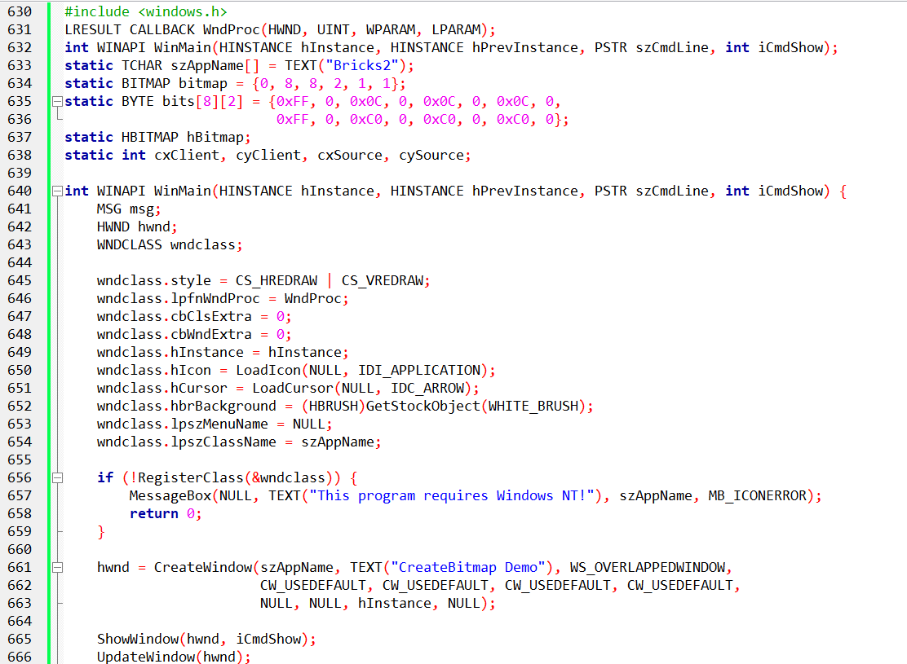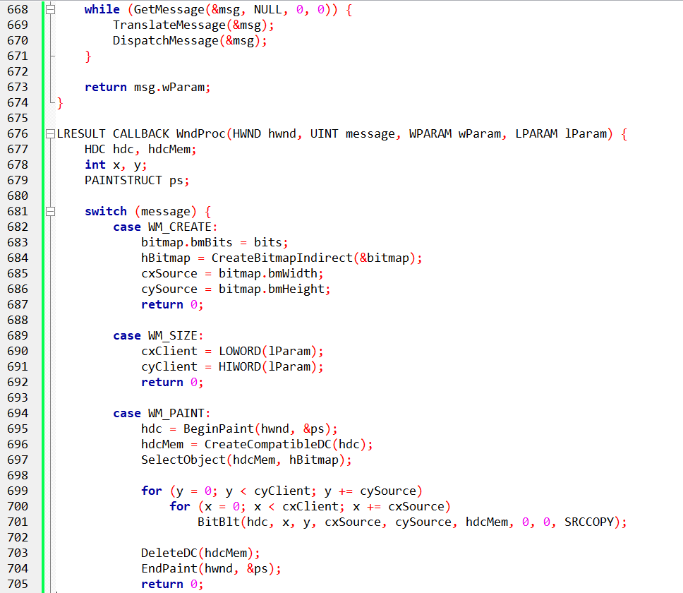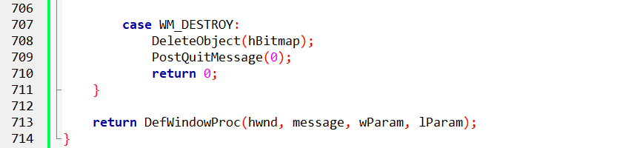

BRICKS2.C: MASTERING MONOCHROME BITMAPS IN GDI

BRICKS2.C delves into the fascinating world of directly creating monochrome bitmaps within your program, offering an alternative to resource-based approaches. Let's dive deep into its code and explain the key aspects:

Defining the Monochrome Bitmap:

static BITMAP bitmap: This structure defines key parameters like width (8 pixels), height (8 pixels), byte width (2 bytes), and color planes (1 for monochrome).

static BYTE bits[8][2]: This two-dimensional array stores the actual bit pattern for the bitmap. Each byte represents 8 pixels, with 1 being white and 0 being black. The two-dimensional structure reflects the 8x8 grid of the bitmap.

Creating the GDI Bitmap Object:

WM_CREATE initializes bitmap.bmBits to point to the bits array, essentially linking the bit data to the structure.

hBitmap = CreateBitmapIndirect(&bitmap): This function creates a GDI bitmap object based on the information provided in the bitmap structure.

Tiling the Bitmap on the Window:

WM_PAINT iterates through the client area using nested loops.

For each iteration, BitBlt copies the entire bitmap from the memory DC (holding the "Bricks" pattern) onto the client DC at specific coordinates.

This effectively tiles the brick pattern across the window, creating the desired visual effect.

Clean Up and Handling Different Messages:

WM_DESTROY deletes the hBitmap object to release resources.

Other messages like WM_SIZE update internal variables based on the new client area dimensions.

Beyond Monochrome, Limitations and Next Steps:

The example highlights the simplicity of this approach for monochrome images.

However, attempting this with a color bitmap under different video modes will fail due to device dependencies.

The next chapter introduces Device-Independent Bitmaps (DIBs), which offer a more flexible and robust solution for handling color bitmaps in GDI.

Key Takeaways:

BRICKS2.C demonstrates direct creation of monochrome bitmaps within your code.

Understanding the bit pattern format and GDI functions like CreateBitmapIndirect empowers you to define custom visuals.

This approach is ideal for simple monochrome images, but limitations arise with color and device compatibility.

Remember:

* Experimentation is key to mastering this technique and exploring its potential.
* The next chapter delves into DIBs, offering a powerful tool for working with color bitmaps in a device-independent manner.

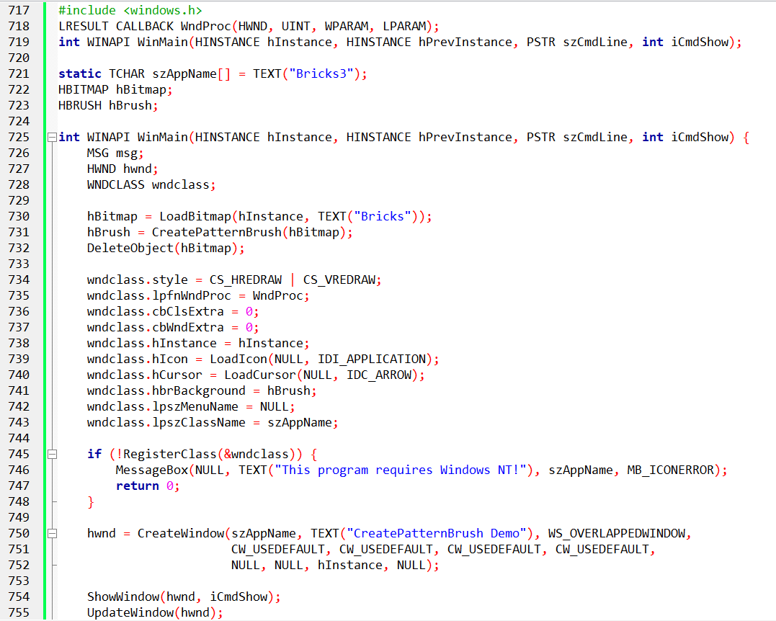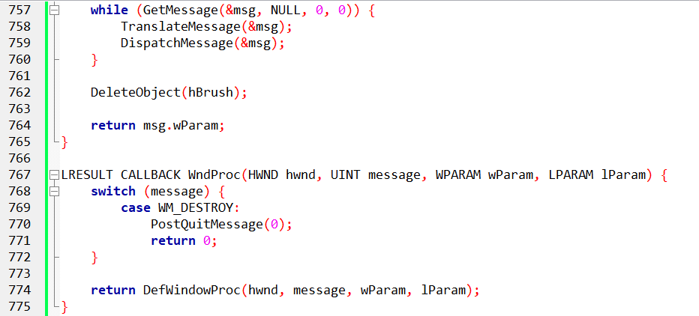

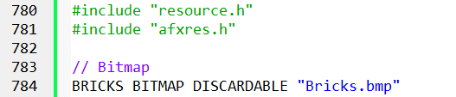

BRICKS3.C: UNVEILING THE POWER OF PATTERN BRUSHES

BRICKS3.C, while seemingly devoid of code at first glance, holds a hidden gem: the magic of pattern brushes. Let's delve deep into its essence and understand how it works:

Creating the Pattern Brush:

The program starts by loading the familiar "Bricks" bitmap using LoadBitmap.

The crucial line lies in creating a pattern brush using CreatePatternBrush with the loaded bitmap as its handle. This function essentially extracts the pattern from the bitmap and turns it into a reusable brush object.

Importantly, the program then deletes the original bitmap, as the pattern information is now captured within the brush.

Setting the Brush as Background:

The WNDCLASS structure for the window is defined, and its hbrBackground field is assigned the newly created pattern brush. This instructs the window to use the "Bricks" pattern as its default background.

The Magic Unfolds:

When the window is created, it automatically inherits the specified background brush. This paints the entire client area with the repeating brick pattern, eliminating the need for explicit drawing commands.

The window procedure handles the WM_DESTROY message by deleting the pattern brush before exiting.

Understanding the Resource File:

The included excerpt from BRICKS3.RC defines a resource called "Bricks" of type BITMAP and specifies the file location as "Bricks.bmp". This ensures the bitmap image is readily available for loading within the program.

Key Takeaways:

* BRICKS3 demonstrates the power of pattern brushes, allowing you to utilize bitmaps as reusable background textures.
* This approach simplifies window drawing by eliminating the need for custom code to paint patterns.
* The resource file ensures convenient access to the bitmap image.

Remember:

* Pattern brushes provide a flexible and efficient way to create visually appealing backgrounds.
* Experimenting with different bitmap patterns can unlock creative possibilities for your applications.

DIVING DEEPER INTO BRICKS3

BRICKS3, while seemingly simple, holds hidden gems that unlock the power of brushes and bitmaps in GDI. Let's delve deeper:

BRICKS3: Reusing the Bricks Pattern as a Brush:

Instead of explicitly drawing the brick pattern, BRICKS3 uses the "Bricks.bmp" image as a source for creating a pattern brush with CreatePatternBrush.

This brush captures the repeating pattern from the bitmap and paints it as the window's background automatically.

The window procedure remains minimal, as the brush handles the repetitive drawing.

Understanding GDI Brushes:

Brushes are small bitmaps, typically 8x8 pixels, used for filling areas with textures or patterns.

You can create brushes from bitmaps using CreatePatternBrush or by setting the BS_PATTERN style in a LOGBRUSH structure used with CreateBrushIndirect.

Windows 98 only utilizes the upper-left corner of the bitmap for brushes exceeding 8x8 pixels, while Windows NT uses the entire image.

Memory Device Contexts and Bitmaps:

We've seen bitmaps used as sources for drawing on windows. But you can also use them as drawing surfaces!

By selecting a bitmap into a memory device context (MDC), you gain an off-screen canvas for drawing.

You can then use various GDI functions like LineTo, Ellipse, or even text rendering on the bitmap within the MDC.

The HELLOBIT program showcases this by displaying "Hello, world!" on a bitmap and then using BitBlt or StretchBlt to transfer it onto the client area.

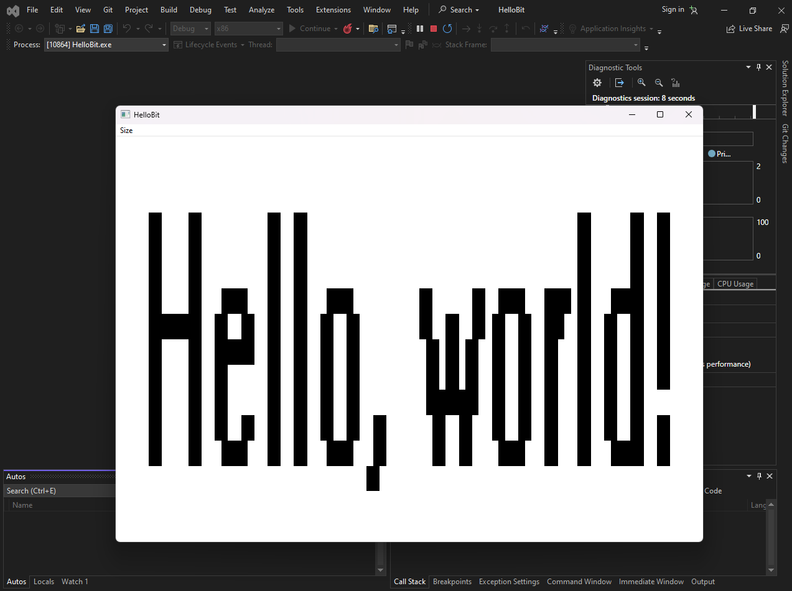

Key Takeaways:

* Brushes offer a powerful way to reuse bitmaps as background textures for windows and other GDI objects.
* Memory device contexts paired with bitmaps provide a flexible canvas for off-screen drawing and manipulation.
* Understanding the differences in bitmap usage between Windows 98 and NT is crucial for optimal results.

Remember:

Experimentation is key to mastering brushes and bitmaps. Try different patterns, drawing techniques, and bitmap sizes to explore their potential.

Always delete GDI objects like brushes and bitmaps when finished to avoid resource leaks.

HELLOBIT: MASTERING BITMAPS AND DRAWING IN GDI

HELLOBIT, at first glance, might appear simple. But beneath its surface lies a fascinating interplay of bitmaps, memory device contexts (MDCs), and drawing techniques. Let's delve deeper:

Creating the Text Bitmap:

Instead of directly drawing text on the window, HELLOBIT creates a dedicated bitmap to hold the "Hello, world!" message.

GetTextExtentPoint32 determines the text size, which defines the bitmap dimensions for compatibility with the video display.

An MDC, also compatible with the display, is created to serve as the off-screen canvas.

TextOut efficiently renders the text onto the bitmap within the MDC, offering precise control over its appearance.

Memory Device Context Magic:

The created MDC and bitmap become key players throughout the program.

The MDC acts as an intermediary, allowing drawing operations on the bitmap without affecting the window directly.

This separation offers flexibility and avoids unnecessary redrawing of the entire window.

Displaying the Text:

Two menu options control how the text bitmap is displayed on the window:

Big: StretchBlt scales the bitmap to fill the entire client area, stretching the text proportionally.

Small: BitBlt copies the bitmap repeatedly across the client area, creating a tiled effect.

Both approaches showcase the versatility of bitmaps and GDI drawing functions.

Important Takeaways:

HELLOBIT demonstrates the power of creating bitmaps for specific drawing tasks.

MDCs provide a convenient off-screen canvas for manipulating and preparing visuals before displaying them on the window.

Understanding different drawing functions like StretchBlt and BitBlt empowers you to manipulate and display bitmaps in various ways.

Additional Points:

While stretching text can lead to pixelation and jagged edges, it serves as an example of bitmap scaling.

HELLOBIT cleans up properly by deleting the MDC and bitmap resources in the WM_DESTROY message.

Remember:

Experiment with different drawing techniques and bitmap manipulation methods to unlock further creative possibilities.

Combining bitmaps with other GDI objects and functions can lead to stunning and dynamic visuals in your applications.

UNVEILING THE TECHNIQUE OF SHADOW BITMAPS: SKETCH TAKES THE STAGE

SKETCH, at first glance, might appear like a simple paint program. But beneath its surface lies a fascinating technique: the power of shadow bitmaps. Let's delve deeper into its secrets:

Building the Shadow Bitmap Canvas:

SKETCH, unlike previous programs, doesn't directly draw on the window. Instead, it creates a hidden "shadow bitmap" that acts as an off-screen canvas.

This bitmap is cleverly sized to accommodate the largest possible display resolution, ensuring compatibility across different systems.

Dedicated memory device contexts (MDCs) are created for both the window and the bitmap, enabling independent drawing operations.

Mouse Magic: Drawing and Erasing:

The program leverages mouse buttons to control drawing and erasing on the shadow bitmap.

Pressing the left mouse button selects a black pen, while the right button switches to a white pen, mimicking an eraser.

As you move the mouse, lines are drawn in the corresponding color onto both the shadow bitmap in the MDC and the actual window.

This real-time update creates the illusion of drawing directly on the window, while maintaining a separate bitmap record.

The Limits of Simplicity:

SKETCH showcases the efficiency of shadow bitmaps, but it also exposes its limitations.

Clearing the entire drawing requires restarting the program, as there's no dedicated "clear" function implemented.

This highlights the trade-off between simplicity and functionality in this basic implementation.

A Homage to History:

The SKETCH program, with its black and white drawing capabilities, pays homage to the early Apple Macintosh advertisements.

It reminds us of the evolution of paint programs and the journey from simple drawing tools to the advanced features we enjoy today.

Key Takeaways:

Shadow bitmaps offer a powerful technique for drawing on windows by utilizing off-screen memory device contexts.

SKETCH demonstrates the effectiveness of this approach while showcasing its limitations and potential for further development.

Understanding the trade-offs between simplicity and functionality allows us to appreciate the advancements in paint programs.

Remember:

Experimenting with different drawing techniques and bitmap manipulation methods can lead to exciting possibilities in your applications.

Combining shadow bitmaps with other GDI functions and objects can unlock even greater visual capabilities.

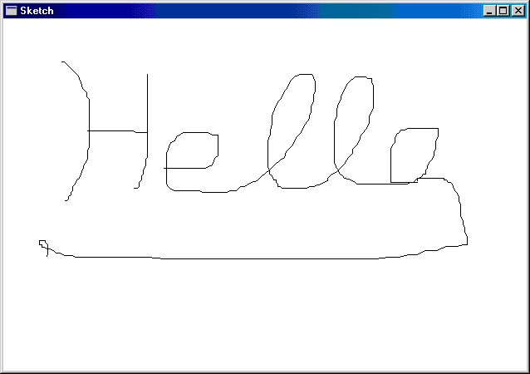

SHADOW BITMAP SIZE IN SKETCH: A BALANCING ACT BETWEEN PERFORMANCE AND FUTURE-PROOFING

SKETCH's shadow bitmap size plays a crucial role in its functionality and efficiency. Let's dive deeper into this balancing act:

Maximizing the Canvas:

Ideally, the shadow bitmap should be large enough to accommodate the entire client area of a maximized window.

This ensures the program can handle any potential window size changes without limitations.

GetSystemMetrics vs. Brute Force:

SKETCH initially attempts to calculate the maximum window size using GetSystemMetrics information. This provides a basic estimate, but doesn't account for future display changes.

The program then employs a "brute force" approach using EnumDisplaySettings to iterate through all available video display modes.

This ensures the shadow bitmap can handle even larger resolutions than the current one, potentially exceeding the current display size by four times or more.

Memory Considerations and Error Handling:

Creating such a large bitmap can be memory-intensive, potentially requiring several megabytes.

SKETCH checks for existing bitmaps to avoid redundant allocation and throws an error if one isn't available, preventing crashes due to memory limitations.

Mouse Capture and Drawing Logic:

SKETCH captures the mouse to track its movements within and outside the window during drawing.

This allows lines to be drawn seamlessly even if the mouse exits the window boundaries while holding the button down.

Implementing more complex drawing logic might necessitate separating the drawing code into two functions, one for each device context (window and bitmap) to maintain code clarity and efficiency.

Window Size Experiment and Shadow Bitmap Persistence:

When drawing with a smaller SKETCH window and then maximizing it, the shadow bitmap surprisingly includes the drawing done outside the original window due to mouse capture.

This highlights the power and potential pitfalls of shadow bitmaps. While it provides a persistent drawing surface, it can also capture unintended actions outside the visible window area.

Key Takeaways:

Choosing the appropriate shadow bitmap size involves balancing future-proofing against memory limitations.

SKETCH's approach offers a comprehensive solution, but alternative methods like dynamic resizing or partial updates could be explored for efficiency.

Understanding the implications of mouse capture and bitmap persistence is crucial for designing intuitive and predictable drawing experiences.

Remember:

Experiment with different shadow bitmap sizing strategies and drawing logic to find the best balance for your specific needs.

Consider factors like memory usage, performance, and user expectations when making decisions about bitmap size and interaction.

BEYOND TEXT: UNLEASHING THE POWER OF BITMAPS IN MENUS

While traditional menus rely solely on text, GRAFMENU pushes the boundaries by incorporating bitmaps, opening doors to a more visual and informative menu experience. Let's delve deeper into its innovative approach:

From Icons to Expressive Elements:

GRAFMENU discards the typical folder, paperclip, and trash can icons, replacing them with expressive bitmaps.

These bitmaps transcend mere decoration; they visually represent menu options, enhancing user understanding and navigation.

Font Powerhouse:

The "FONT" menu showcases the potential of bitmaps in displaying different fonts and sizes.

Each option in the popup menu utilizes a bitmap with the actual font applied, providing a clear preview of what the user selects.

Beyond Icons: Hatch Patterns, Colors, and More:

Imagine menu items with line width options visualized through bitmaps with varying line thicknesses.

Hatch patterns for fill styles could be represented directly, offering users an immediate visual reference.

Colors can come alive with bitmaps showcasing different palettes or custom color combinations.

The Power of Memory Device Contexts:

GRAFMENU demonstrates how memory device contexts (MDCs) empower bitmap creation within the program.

These MDCs act as off-screen canvases, allowing you to design and manipulate bitmaps without affecting the actual menu appearance.

Visual Hierarchy and Storytelling:

The "Help" bitmap in the system menu adds a subtle touch of humor and visual storytelling, subtly hinting at the potential frustration of new users.

This demonstrates how bitmaps can go beyond mere functionality and inject personality into the user interface.

Key Takeaways:

Bitmaps offer a powerful way to enrich menu items beyond simple text, enhancing user understanding and engagement.

MDCs provide a flexible platform for creating and manipulating bitmaps within your program without affecting the actual menu display.

Experimenting with different bitmap designs, including fonts, line styles, colors, and even humor, can unlock new possibilities for intuitive and expressive menus.

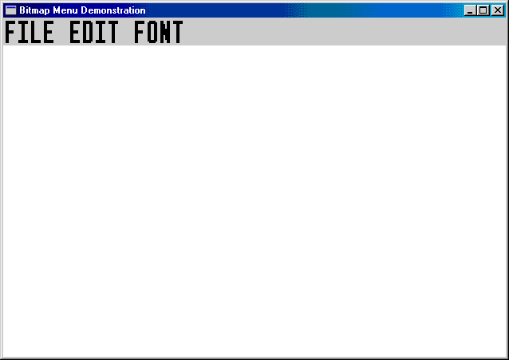

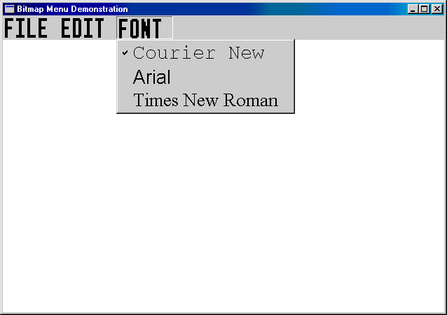

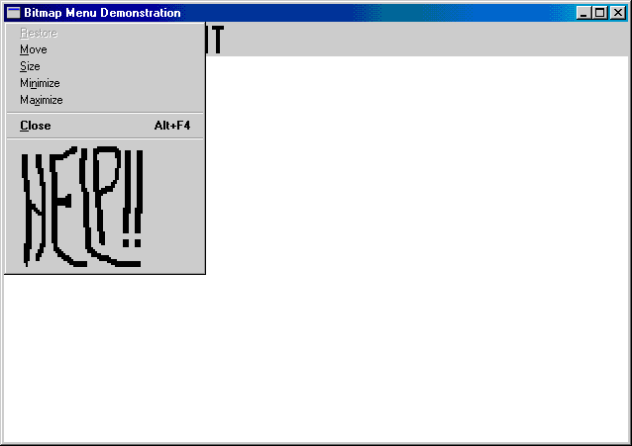

Remember:

While bitmaps offer great flexibility, ensure their design is clear, consistent, and aligns with your program's overall aesthetic.

Accessibility considerations are crucial; ensure bitmap-based menus are accessible for users with visual impairments.

GRAFMENU: UNPACKING THE PROGRAM'S FUNCTIONALITY

GRAFMENU is a program that demonstrates the use of bitmaps in menus, going beyond the typical text-based options. Here's an in-depth explanation of its code and functionalities:

Menu Structure:

The program utilizes two resource files: GRAFMENU.RC defines the menu structure and RESOURCE.H contains resource IDs for menu items and bitmaps.

Two separate menus are defined: MENUFILE for file-related actions and MENUEDIT for editing functionalities.

Bitmap Magic:

GRAFMENU leverages bitmaps to visually represent menu options instead of text. This adds a layer of visual clarity and intuitiveness.

Four bitmaps are used:

* BitmapFile for the "File" menu.
* BitmapEdit for the "Edit" menu.
* BitmapFont for the "Font" submenu label.
* BitmapHelp for the "Help" menu item in the system menu.

Each bitmap is loaded from a resource file and stretched to fit the display resolution, ensuring consistent visual quality across different systems.

Font Powerhouse:

The "Font" submenu showcases the power of bitmaps in representing different fonts.

Three bitmaps are dynamically generated using memory device contexts (MDCs):

One for each font type (Courier New, Arial, Times New Roman) with the actual font name drawn on it.

This allows users to visually see the font before selecting it, enhancing user experience and clarity.

System Menu Integration:

GRAFMENU adds a custom "Help" item to the system menu using a bitmap.

This adds a touch of personality and visual interest to the program.

Functionality and Event Handling:

The program defines various menu item IDs and handles user interactions through the WndProc function.

Selecting menu items triggers specific actions like displaying the "Help" message box or checking/unchecking font options.

When the program closes, all bitmaps used in the menus are properly deleted to avoid memory leaks.

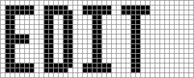

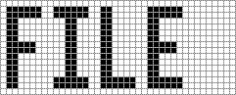

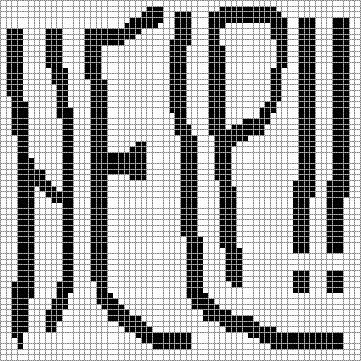

Key Takeaways:

GRAFMENU demonstrates a creative and innovative approach to menu design using bitmaps.

It highlights the potential of bitmaps to enhance user experience by providing visual cues and improving clarity.

The program's code provides valuable insights into bitmap manipulation, resource handling, and menu interaction techniques.

Further Exploration:

Experiment with different bitmap designs and styles to create unique and visually appealing menus.

Consider implementing dynamic bitmap generation based on menu item states or user preferences.

Explore incorporating sound effects or animations for an even more engaging user experience.

Remember, GRAFMENU is just one example of how bitmaps can be used to enhance menu functionality. Be creative, experiment, and push the boundaries of menu design!

DEEP DIVE INTO GRAFMENU'S BITMAP MAGIC: UNPACKING THE CODE

GRAFMENU leverages bitmaps to create visually captivating and informative menus, deviating from the typical text-based approach. Here's a detailed breakdown of the code and its functionalities:

1. Menu Creation and Structure:

CreateMyMenu: This function assembles the main menu by:

* Creating an empty menu with CreateMenu.
* Loading the "MenuFile" popup for File options using LoadMenu.
* Stretching and loading the "BitmapFile" bitmap for the File menu label with StretchBitmap and LoadBitmap.
* Appending the File menu bitmap and popup to the main menu with AppendMenu.

Similarly, the Edit menu is created with its popup and bitmap.

2. Dynamic Font Bitmaps:

GetBitmapFont: This function generates a bitmap displaying a specific font name.

* It takes an integer parameter (0, 1, or 2) corresponding to the desired font: "Courier New", "Arial", or "Times New Roman".
* It uses CreateIC and GetTextMetrics to obtain the screen's device context and system font size.
* A memory device context compatible with the screen is created with CreateCompatibleDC.
* A logical font twice the system font size with the chosen facename is created using CreateFont.
* The SelectObject function selects this font into the memory device context, saving the system font handle.
* GetTextExtentPoint32 retrieves the text dimensions, and CreateBitmap creates a bitmap based on those dimensions.
* The text is written to the bitmap using TextOut.
* Finally, the system font is reselected, the temporary font deleted, and both device contexts released.

3. Scaling Bitmaps for Different Resolutions:

StretchBitmap: This function scales a bitmap to fit the current display resolution.

* It retrieves the screen's device context and system font metrics.
* Two memory device contexts are created compatible with the screen.
* The provided bitmap handle is obtained, and its dimensions are retrieved with GetObject.
* A new BITMAP structure with adjusted dimensions based on the system font size is created.
* A new bitmap with the adjusted dimensions is created using CreateBitmapIndirect.
* Both bitmaps are selected into their respective memory device contexts.
* StretchBlt is used to copy and stretch the original bitmap onto the new one.
* Finally, the temporary bitmap and device contexts are cleaned up.

4. Integrating Bitmaps into Menus:

CreateMyMenu uses StretchBitmap and GetBitmapFont to create bitmaps for the Font submenu options.

* These font bitmaps and the "BitmapFont" label are appended to the Edit menu popup using AppendMenu.
* The WndProc function handles menu interactions, responding to selections and checking/unchecking font options.

Key Takeaways:

GRAFMENU demonstrates:

* Creating bitmaps from scratch and loading them from resources.
* Scaling bitmaps to fit different display resolutions.
* Integrating bitmaps into menus for visual clarity and user experience enhancement.

Further Exploration:

* Experiment with generating different bitmap styles and designs for menu items.
* Implement dynamic bitmap generation based on menu item states or user preferences.
* Combine bitmaps with sound effects or animations for a more interactive menu experience.

Remember, GRAFMENU is just one example of using bitmaps for innovative menu design. Be creative, explore the possibilities, and push the boundaries of user interface design with the power of bitmaps!

Bonus:

The provided codebox can be incorporated into the explanation to illustrate specific functions like GetBitmapFont or StretchBitmap. This would further enhance the understanding of how each piece of code contributes to the overall functionality of GRAFMENU.

GRAFMENU'S MENU IN DEPTH

GRAFMENU's menu design goes beyond the usual text-based options, employing captivating bitmaps for both visual appeal and clarity. Let's delve deeper into how this is achieved:

Building the Edit Menu:

Loading Popup Menu: Similar to the File menu, LoadMenu retrieves the pre-defined "MenuEdit" popup from the resource file.

Stretching Edit Label: The "BitmapEdit" bitmap is loaded and then scaled using StretchBitmap to fit the current display resolution.

Adding to Main Menu: AppendMenu combines the stretched bitmap and the edit popup into a single menu item for the main menu.

Constructing the Font Submenu:

Creating Empty Popup: A blank popup menu is created with CreateMenu to hold the font options.

Generating Font Bitmaps: A loop iterates through three font options (Courier New, Arial, Times New Roman). For each, GetBitmapFont generates a bitmap displaying the corresponding font name.

Adding Font Options: Each font bitmap is appended to the popup menu as a separate item using AppendMenu. The provided IDM_FONT_COUR + i identifies each option uniquely.

Completing the Window Menu:

Stretching Font Label: Similar to the Edit menu, the "BitmapFont" label is stretched to the appropriate size using StretchBitmap.

Adding Font Submenu: The stretched font label and the font popup are combined into another menu item for the main menu with AppendMenu.

Setting Menu: Finally, SetMenu assigns the completed window menu to the program window.

Enhancing the System Menu:

GetSystemMenu retrieves the existing system menu handle.

The "BitmapHelp" image is loaded and scaled using StretchBitmap for optimal display.

A separator and the stretched help bitmap are appended to the system menu using AppendMenu, providing easy access to help.

Cleaning Up and Miscellaneous Notes:

GRAFMENU dedicates a function to properly disposing of all bitmaps before program termination.

Some additional points to consider:

* In top-level menus, Windows automatically adjusts the menu bar height to accommodate the tallest bitmap.
* Checkmarks can be used with bitmapped popup items, but they appear in the standard size. Customized checkmarks and SetMenuItemBitmaps offer alternative solutions.
* "Owner-draw" menus provide another approach for displaying non-text content or custom fonts.
* Keyboard navigation for bitmapped menus requires handling the WM_MENUCHAR message to interpret user key presses and associate them with specific menu items.

Conclusion:

GRAFMENU demonstrates the potential of bitmaps in menu design, offering visual clarity and enhancing user experience. By understanding the code breakdown and the underlying principles, you can gain valuable insights into creating your own innovative and captivating menu interfaces.

DEEP DIVE INTO BITMASK: MASKING BITMAPS FOR ELLIPTICAL SHAPES

BITMASK showcases an ingenious technique for displaying non-rectangular bitmap images, specifically how to turn a rectangular image into an ellipse. Let's dive deeper into the code and understand the magic behind this visual transformation:

1. Setting the Stage:

The WndProc function handles all window messages.

Global variables store handles for the original image (hBitmapImag), mask bitmap (hBitmapMask), and WinMain's instance (hInstance).

cxClient and cyClient hold the client area dimensions, while cxBitmap and cyBitmap store the image dimensions obtained from GetObject.

2. Image Preparation:

WM_CREATE loads the image using LoadBitmap and retrieves its size with GetObject.

A compatible memory DC (hdcMemImag) is created and the image is selected into it.

3. Mask Creation and Transformation:

A monochrome mask bitmap with the same dimensions as the image is created with CreateBitmap.

Another compatible memory DC (hdcMemMask) is created and the mask is selected into it.

The mask is first filled black using SelectObject and Rectangle, then a white ellipse is drawn using SelectObject and Ellipse.

4. Masking the Image:

The BitBlt function performs the magic. It uses the SRCAND raster operation, which combines the source (image) and destination (mask) bitmaps pixel-by-pixel.

White pixels in the mask allow the corresponding image pixels to show, while black pixels hide them, creating the desired elliptical shape.

5. Painting the Elliptical Image:

WM_PAINT updates the display.

Compatible memory DCs are created for both the image and mask bitmaps.

The image is centered in the client area using calculations involving cxClient, cyClient, cxBitmap, and cyBitmap.

Two BitBlt operations are performed:

The first uses the mask with the 0x220326 raster operation to erase unwanted areas and create the elliptical outline.

The second uses the SRCPAINT operation to paint the masked image within the ellipse.

Finally, the memory DCs are cleaned up.

6. Cleanup and Completion:

WM_DESTROY releases the image and mask bitmaps before exiting the program.

Key Takeaways:

BITMASK demonstrates how a mask bitmap and the BitBlt function with specific raster operations can create non-rectangular image displays.

This technique allows you to display bitmaps in various shapes, not just rectangles, enhancing visual interest and design flexibility.

Understanding the code breakdown and the principles behind masking empowers you to implement similar techniques in your own applications.

Further Exploration:

Experiment with different mask shapes and bitmap content to create unique visual effects.

Explore other raster operations and their combinations for more advanced masking possibilities.

Combine masking with other graphical techniques like transparency and alpha blending for even richer visual experiences.

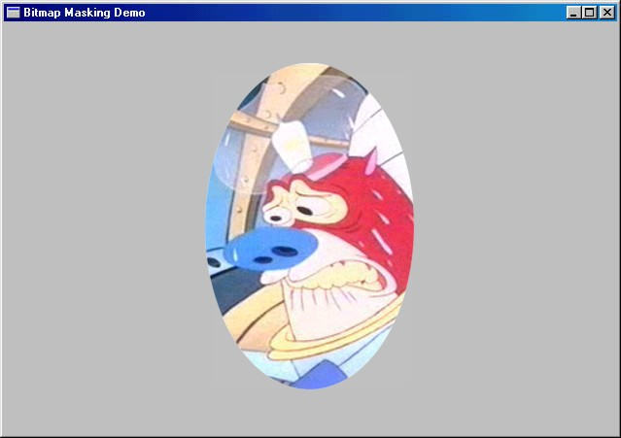

DIVING DEEPER INTO BITMASK'S NOTES:

1. Versatile Mask Potential:

BITMASK isn't limited to Matthew's picture; it can display any image using the same masking technique.

The MATTHEW.BMP file simply acts as a placeholder for any bitmap you want to transform.

2. Gray Background Verification:

The light gray background serves as a visual confirmation that the masking is working correctly.

If the image remained entirely white after masking, it would be difficult to distinguish between proper masking and simply painting the image white.

3. Bitwise Magic in Masking:

The SRCAND operation in WM_CREATE performs a bitwise AND between the mask (1s for white, 0s for black) and the image (1s for set pixels, 0s for unset pixels).

This operation retains image pixels where the mask is white (1) and sets them to black where the mask is black (0), effectively creating the elliptical shape.

4. Elliptical Window Outline:

The first WM_PAINT BitBlt uses a custom raster operation (D & ~S) to achieve the black ellipse outline.

This operation inverts the mask (black ellipse becomes white, white background becomes black) and then performs an AND with the window surface.

This AND operation sets the window pixels to black wherever the inverted mask is black, creating the desired elliptical outline.

5. Image Display within the Ellipse:

The second WM_PAINT BitBlt uses SRCPAINT to overlay the masked image onto the window.

SRCPAINT performs a bitwise OR, leaving the window background untouched and copying the image pixels within the ellipse onto the window surface.

Additional Notes:

Creating complex masks, like ones that completely erase the original background, may require manual manipulation in a paint program.

Experimenting with different mask designs and raster operations unlocks further possibilities for creative image manipulation within the BITMASK framework.

Remember:

This explanation avoids technical jargon and focuses on the underlying concepts and logic of the masking process.

The goal is to provide a clear understanding of how BITMASK achieves its visual transformation without getting bogged down in the specifics of the code.

DEEP DIVE INTO BOUNCE: BOUNCING BALL ANIMATION EXPLAINED

BOUNCE showcases a basic animation technique using a bitmap and a timer to bring a ball to life on the screen. Let's delve deeper into the code and understand how it works:

1. Setting the Stage:

The program defines constants and global variables like hBitmap for the bitmap handle and xCenter, yCenter for the ball's position.

WM_CREATE retrieves device pixel aspect ratios for scaling the ball and sets a timer to trigger animation updates every 50 milliseconds.

2. Ball Construction and Scaling:

WM_SIZE recalculates the client area dimensions and adjusts the ball size accordingly.

It scales the ball diameter to 1/16th of the smaller dimension (height or width) and adds a margin for smooth movement.

A memory DC compatible with the video display is created for drawing the ball bitmap.

3. Drawing the Ball with a Hatch and Margin:

A compatible bitmap with the desired size (cxTotal, cyTotal) is created in memory.

The entire bitmap is filled white using Rectangle to erase any previous ball remnants.

A diagonally hatched brush is selected and used to draw the ball as an ellipse within the bitmap, leaving margins around its edges.

4. Animation Loop and Ball Movement:

The timer triggers WM_TIMER at regular intervals to update the ball's position.

The program uses GetDC and CreateCompatibleDC to access memory DCs for drawing and blitting.

A BitBlt operation with SRCCOPY copies the entire ball bitmap onto the window at the new center coordinates (xCenter, yCenter).

The ball's center coordinates are incremented by cxMove and cyMove to simulate movement.

Boundary checks ensure the ball bounces off the window edges by reversing its direction when it reaches the limits.

5. Cleaning Up and Ending the Animation:

WM_DESTROY releases the bitmap handle and kills the timer before exiting the program.

Points to Ponder:

This implementation is a basic example; advanced animation techniques involve other ROP codes for blending and effects.

The Windows palette and AnimatePalette function offer additional animation possibilities.

For more sophisticated animation, exploring DirectX or other animation libraries is recommended.

Key Takeaways:

BOUNCE demonstrates how a simple bitmap and timer combination can create basic animation.

Understanding the code logic behind drawing, movement, and collision detection provides a foundation for exploring more complex animation techniques.

By experimenting with different ROP codes, palette manipulation, and advanced libraries, you can create more visually engaging and dynamic animations in your Windows applications.

DEEP DIVE INTO SCRAMBLE'S NOTES: SCRAMBLED SECRETS EXPLAINED

1. Rude But Revealing:

SCRAMBLE may seem mischievous, but it showcases advanced techniques for manipulating screen content using memory device contexts (DCs).

2. Locking the Screen:

LockWindowUpdate prevents other programs from updating the screen while SCRAMBLE works its magic, ensuring smooth scrambling.

GetDCEx with DCX_LOCKWINDOWUPDATE acquires a device context for the entire screen, giving SCRAMBLE direct access.

3. Dimension Downscaling:

Dividing the full screen size by 10 creates smaller rectangles for swapping, preventing the entire screen from flickering at once.

This also reduces the computational burden, making the scrambling smoother.

4. Memory DC as Temporary Storage:

A compatible memory DC acts as a temporary holding space for the swapped rectangles.

This avoids rewriting the entire screen directly, making the process more efficient.

5. The Choreographed Swap:

Three BitBlt operations orchestrate the rectangle exchange:

* Copy to Memory: The first BitBlt copies the first rectangle to the memory DC.
* Overlay Replacement: The second BitBlt overwrites the first rectangle area with the second rectangle from the screen.
* Memory to Screen: The third BitBlt copies the swapped rectangle from the memory DC back onto the second rectangle area.

6. Unscramble and Unlock:

SCRAMBLE remembers the swapping order and reverses the process, restoring the original screen before unlocking it.

This ensures you get your unscrambled screen back after the visual chaos!

7. Beyond Swapping:

Memory DCs can also copy specific portions of bitmaps. The code snippet demonstrates extracting a bitmap's upper left quadrant.

This technique opens doors for more creative bitmap manipulations and image composition within your Windows applications.

Remember:

SCRAMBLE is a playful example, but it highlights powerful techniques for manipulating screen content and bitmaps using memory DCs.

Understanding the core principles behind these operations empowers you to explore more sophisticated visual effects and image processing tasks in your Windows development projects.